**RESTAURANT MANAGEMENT SYSTEM**

**RESTX**

**Problem no.:**

**10. Restaurant management service It will be a GUI based system where model restaurant will take order from its customer and generate bill. System will have a backend database and restaurant staff/admin will update the data as new menu items, change of rate, discount etc.**

**Contents**

1. About the project
2. Technology used
3. Setting up the environment
   1. Download and install Java SE JDK
   2. Download and install Apache NetBeans
   3. Download and install XAMPP
   4. Initialize XAMPP
4. Proceeding with project work
   1. Prepare the database
   2. Running the project
   3. Main components for building
   4. Project Workflow with screenshots
   5. Demonstration of the project
   6. Discussion
5. Important
   1. Important 1

**About the project**

**RESTX** is a java application working as a basic restaurant management system. It helps to build a restaurant environment and billing for the products.

**Technology with versions**

* Java 11.0.6 2020-01-14 LTS
* Apache NetBeans 11 LTS
* XAMPP 7.4.4-0
* Apache server
* Phpmyadmin
* MySQL

**Setting up the environment**

This project is created using NetBeans IDE on the Windows 10 operating system and using MySQL as its backend database management system.

* **Download and install JAVA SE development kit** **from [https://www.oracle.com/java/technologies/javase-jdk11-downloads.html#license-lightbox](https://www.oracle.com/java/technologies/javase-jdk11-downloads.html" \l "license-lightbox).** Now set up environment variables. Go to **Control panel -> System and Security -> System -> Advanced system settings -> Environment Variables.**

Go to Path -> Edit -> New -> Add **C:\Program Files\Java\jdk-11.0.6\bin**

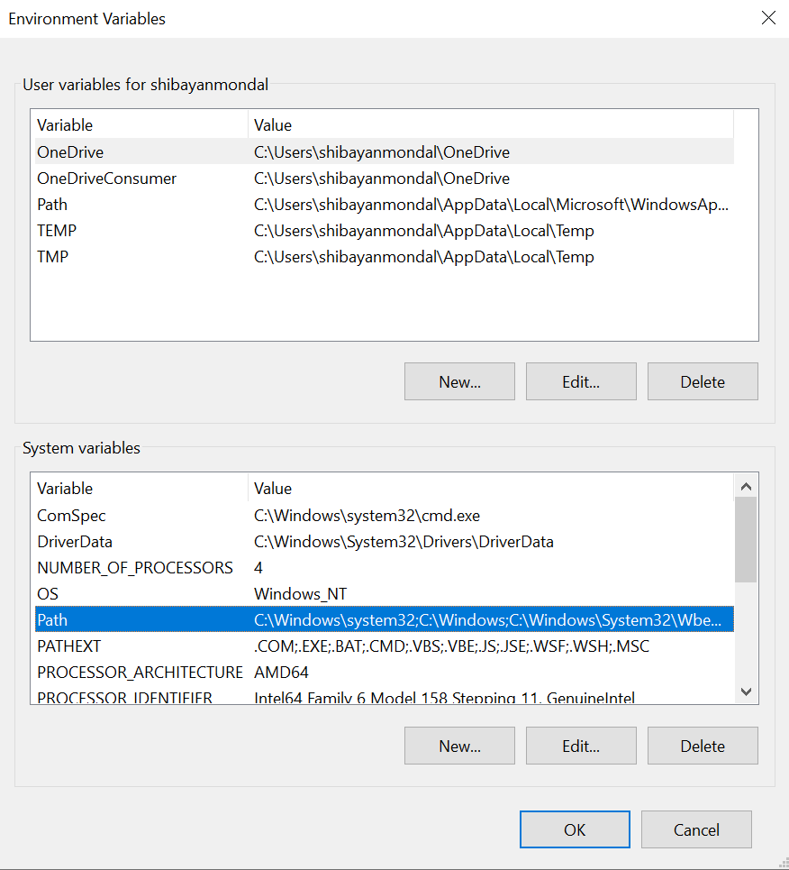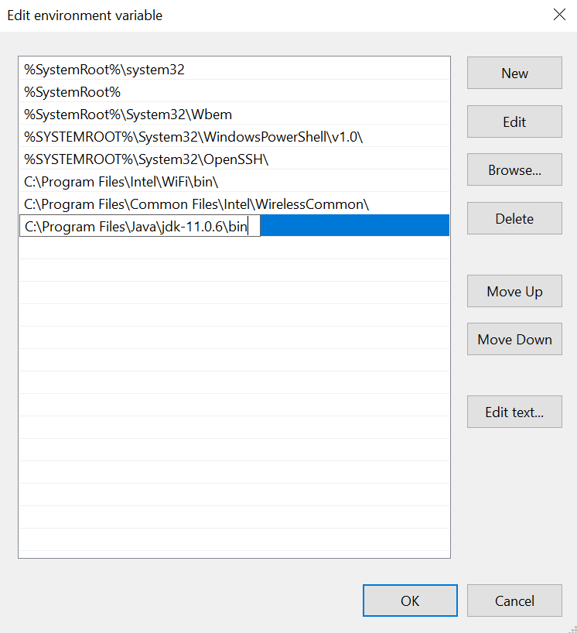

Now check if Java environment is running or not. Open command prompt and type **javac --version or java --version.** If you see the version, you are good to go.

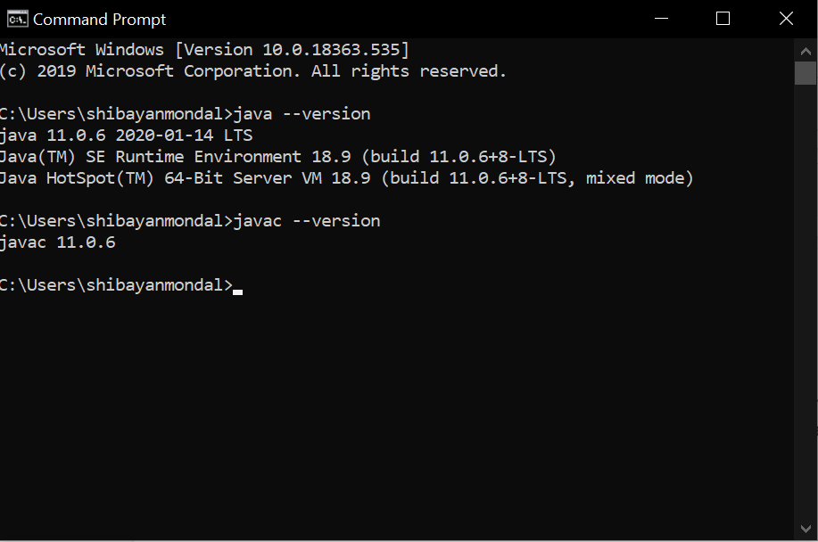

* **Download and install Apache NetBeans 11 LTS from <https://downloads.apache.org/incubator/netbeans/incubating-netbeans/incubating-11.0/incubating-netbeans-11.0-bin.zip>.** Create a folder **“netbeans”** and unzip the file inside it. Then move the folder **netbeans** in **C:\ and** open **\bin** inside it.Open **netbeans64** and do **pin to taskbar**.

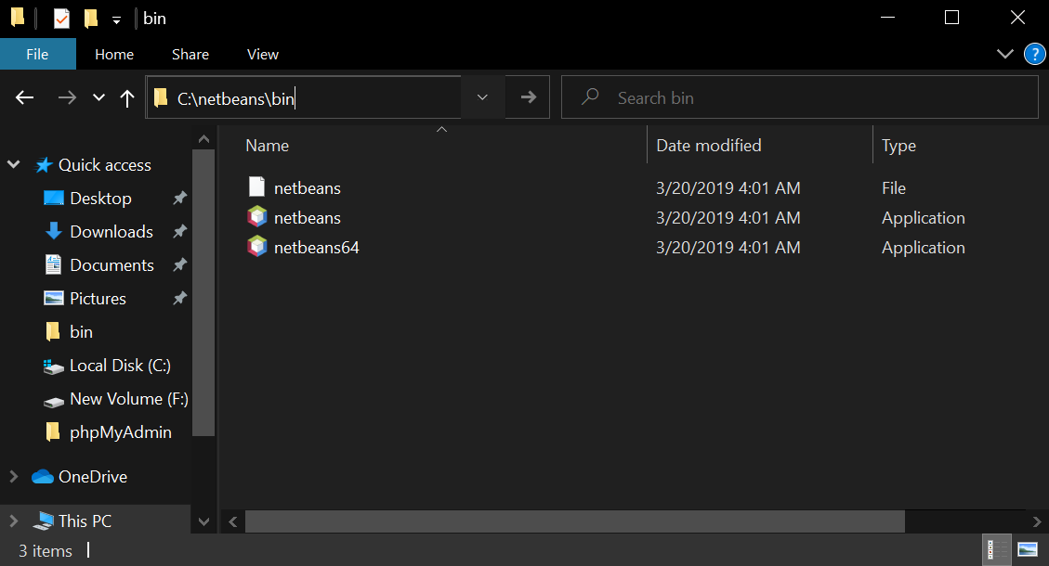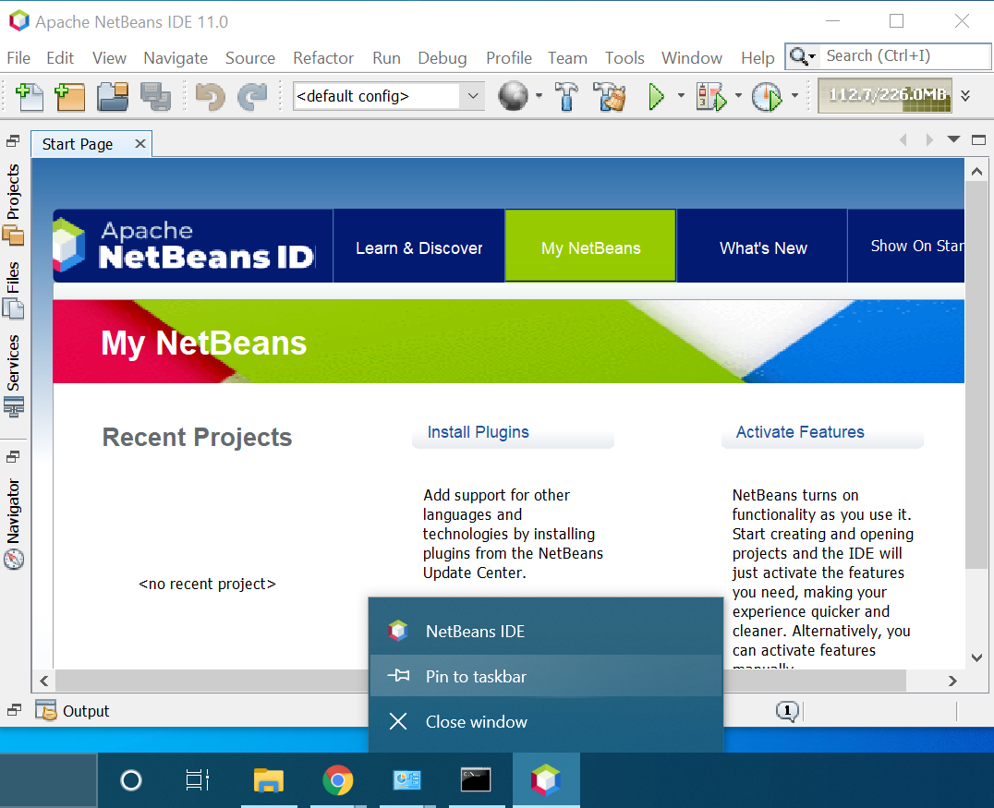

* 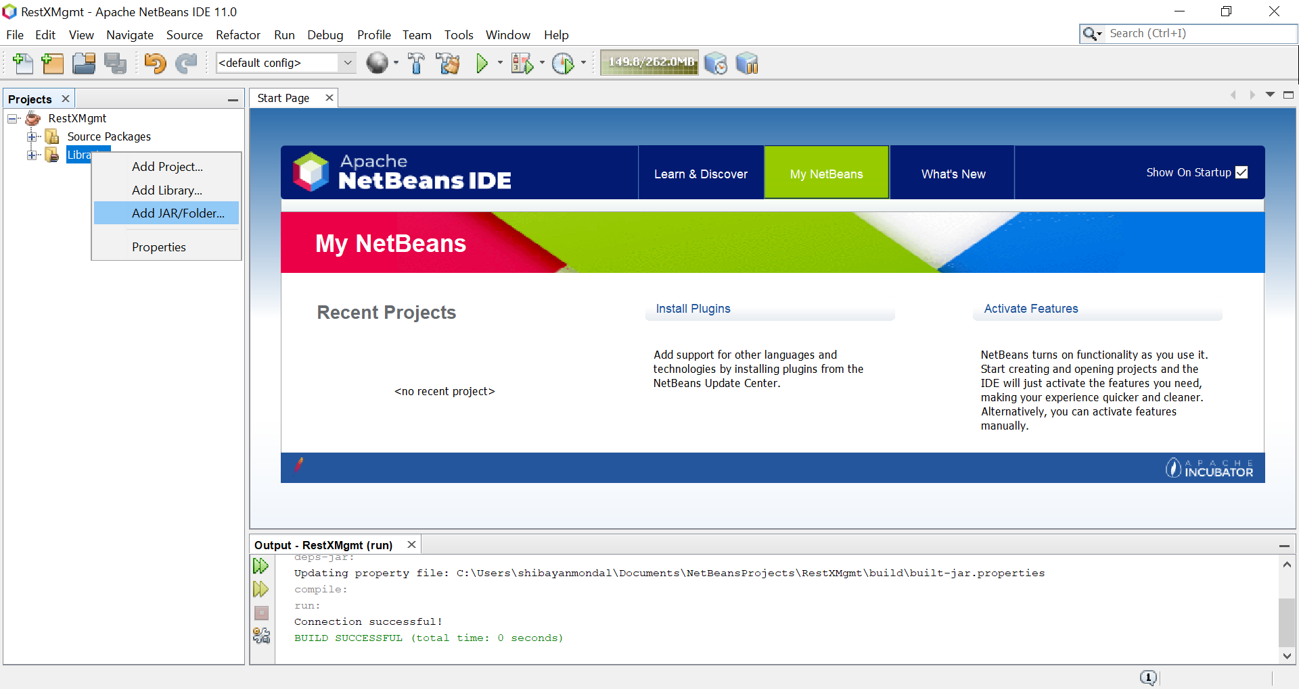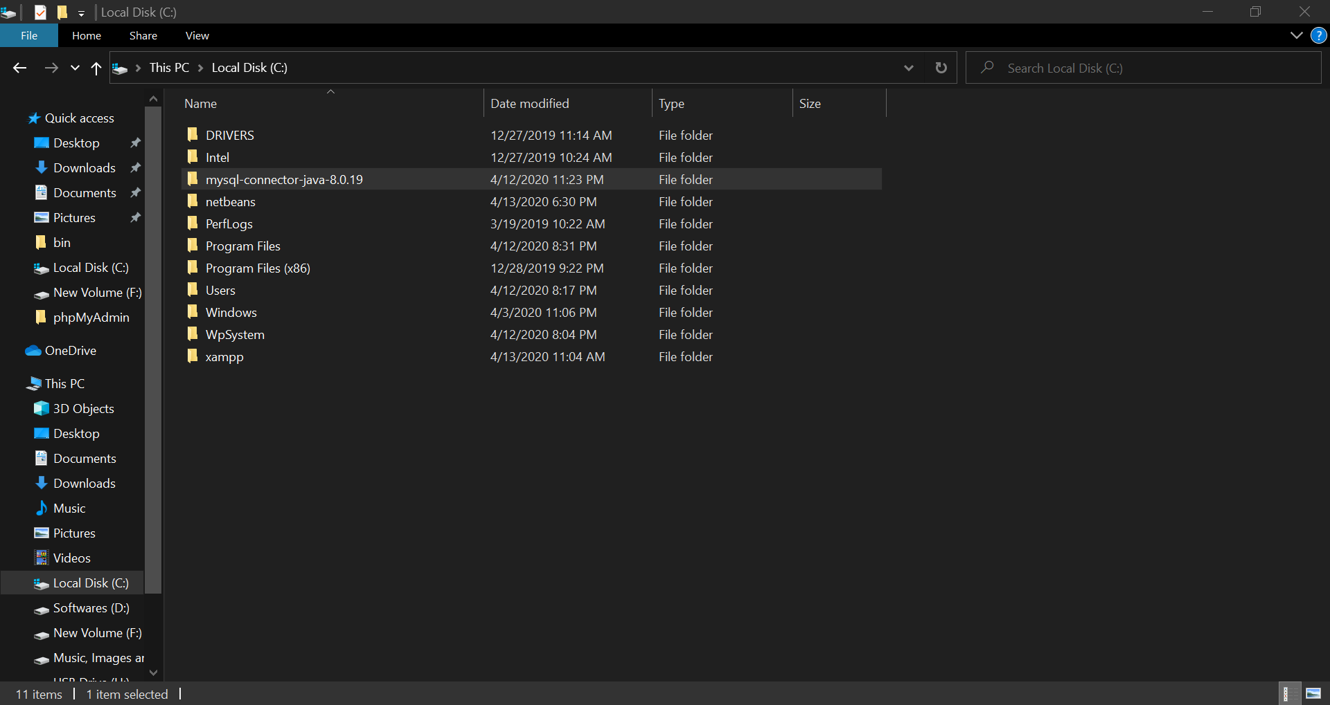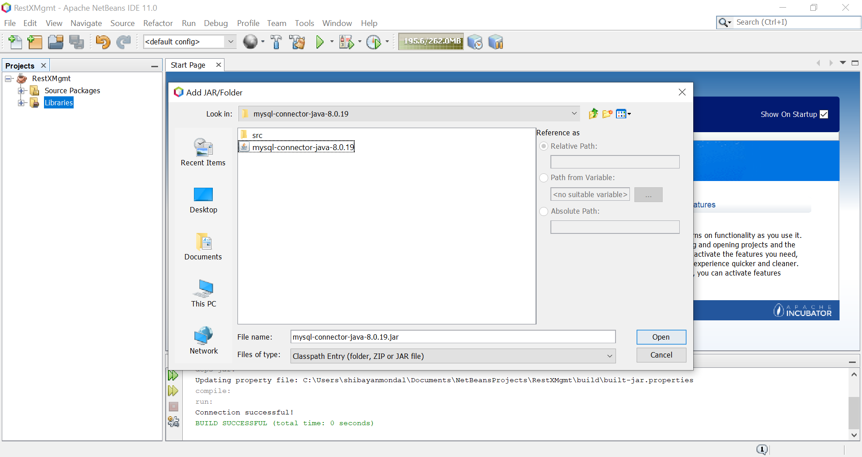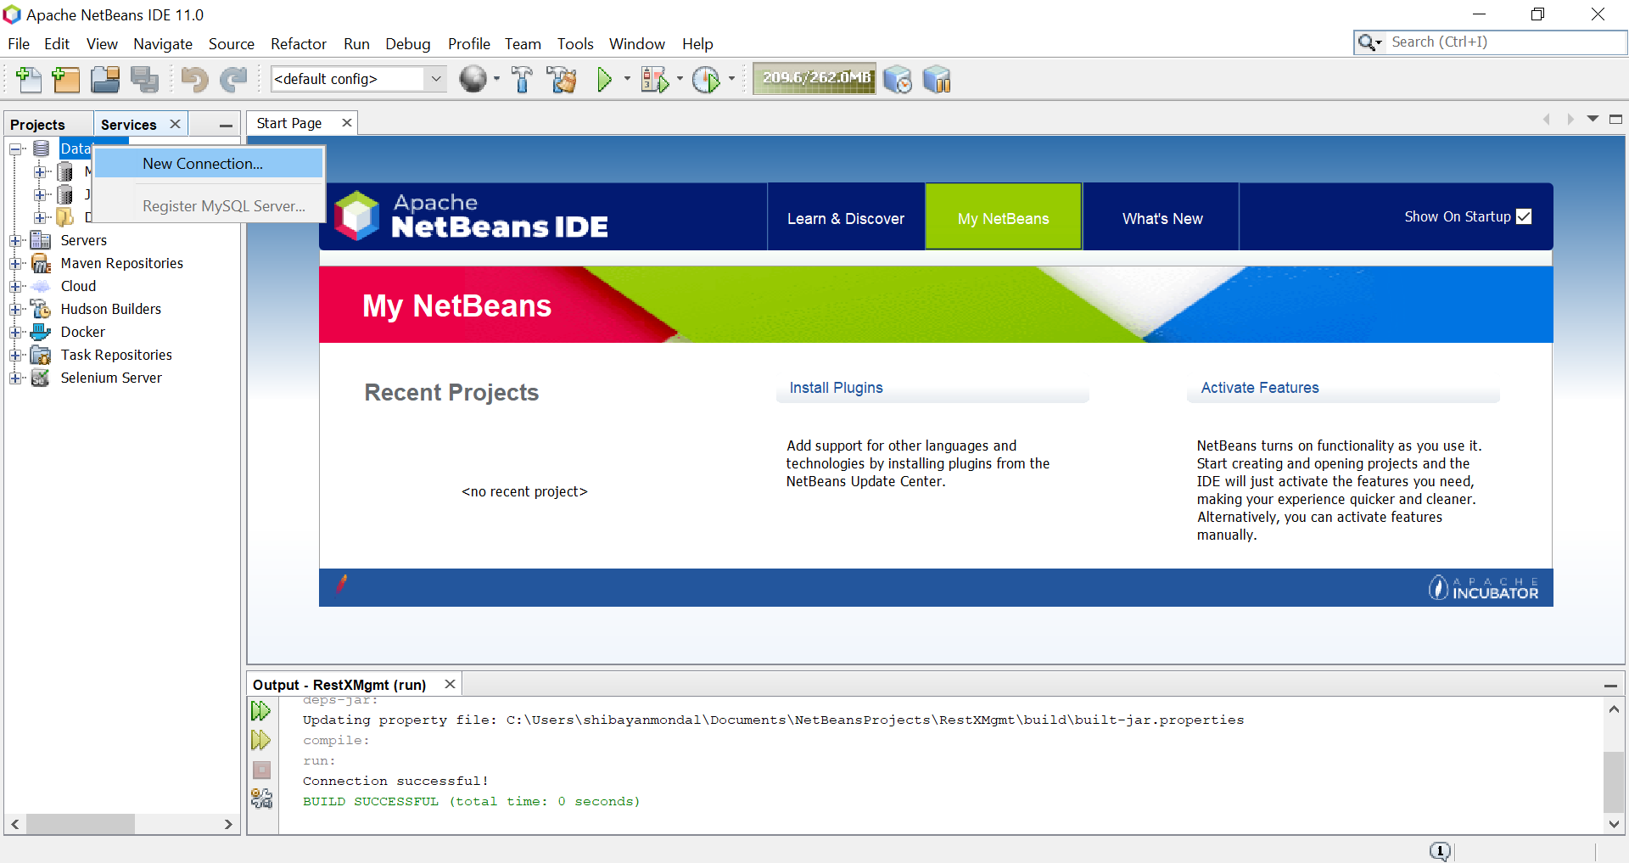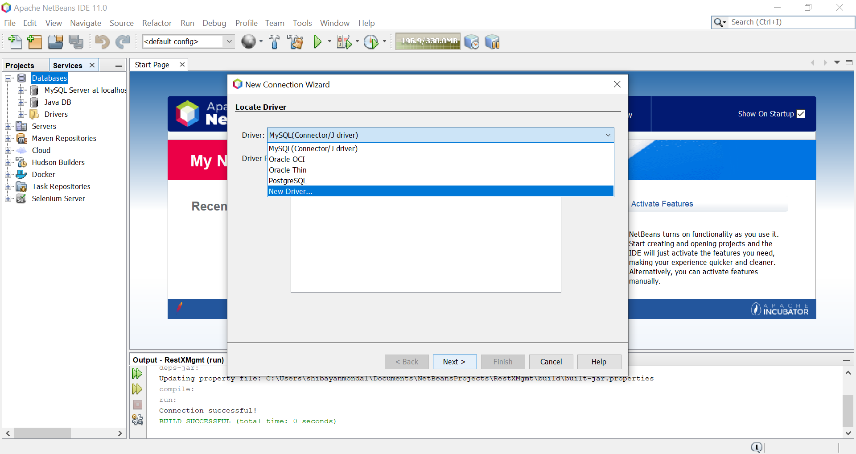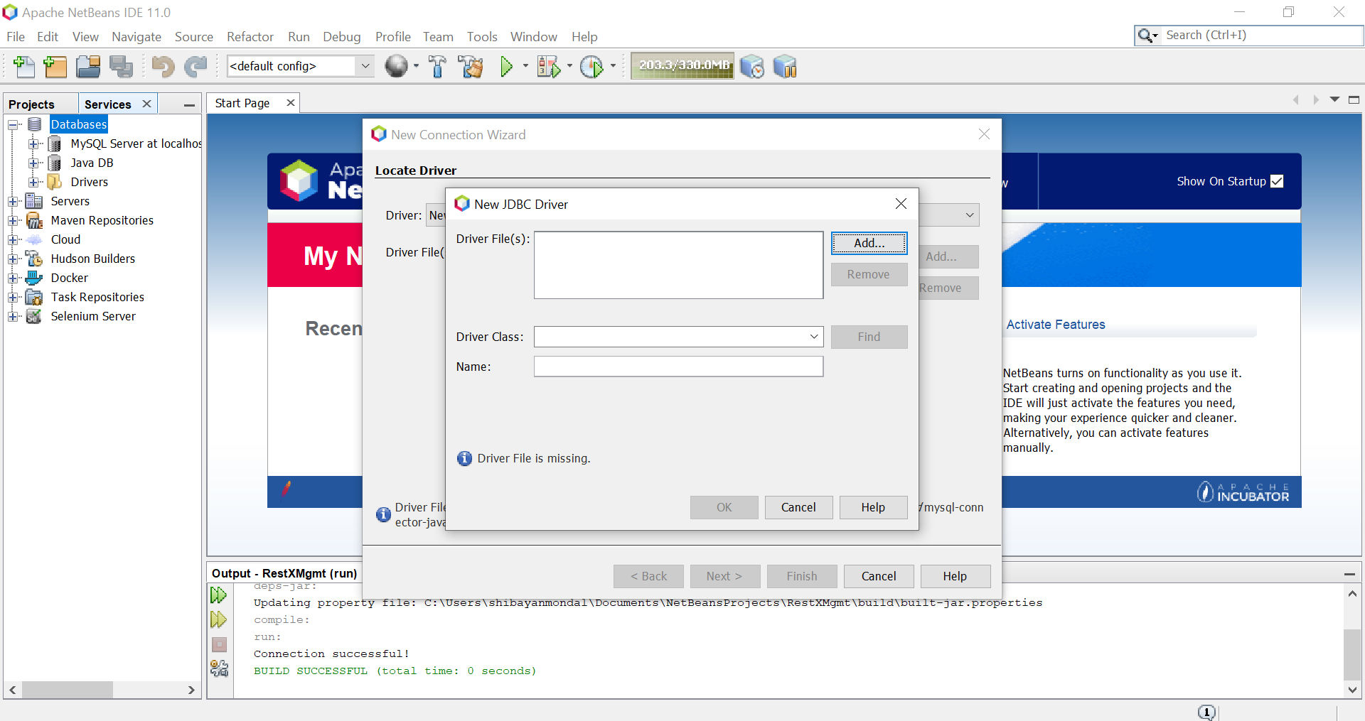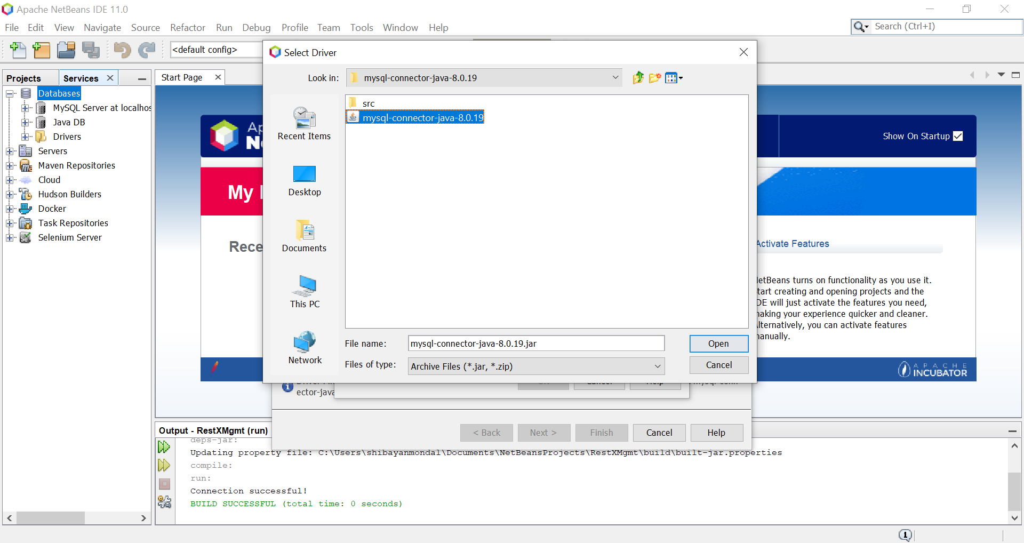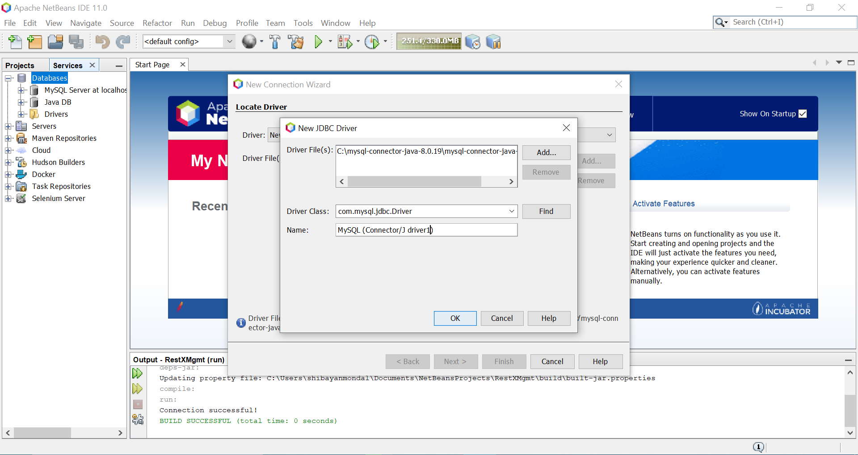**Download and install XAMPP from <https://www.apachefriends.org/xampp-files/7.4.4/xampp-windows-x64-7.4.4-0-VC15-installer.exe.>** Install it to the directory **C:\xampp.**

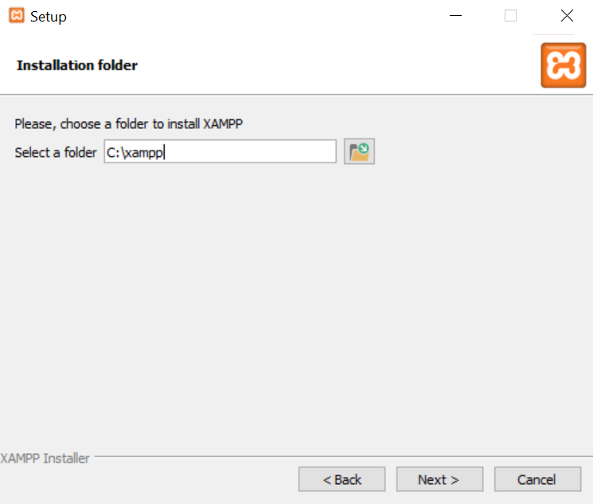

Now, open **xampp** folder inside **C:\**. Scroll down until **xampp-control** is found. Right-click on it and go to **Properties -> Compatibility and enable Run this program as administrator.**

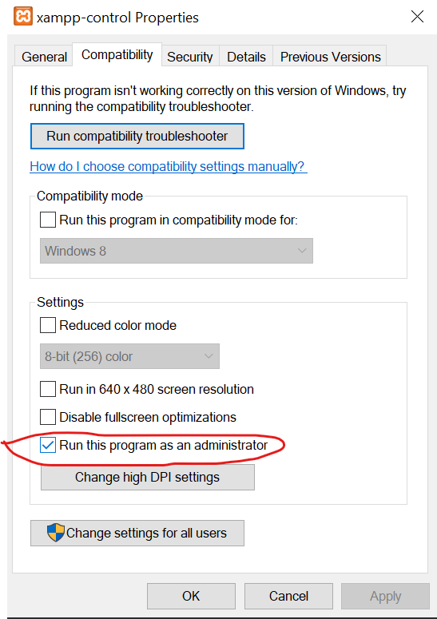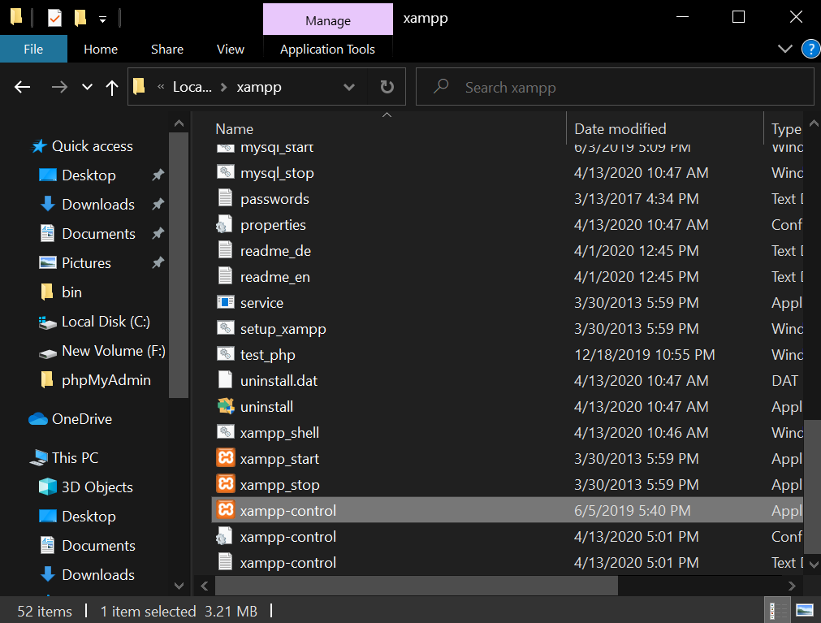

* **Open XAMMP Control Panel and start Apache and MySQL.** If a red cross is seen at the left side then click on it and install to make it green check.

Otherwise, skip the step and click on **Start.**

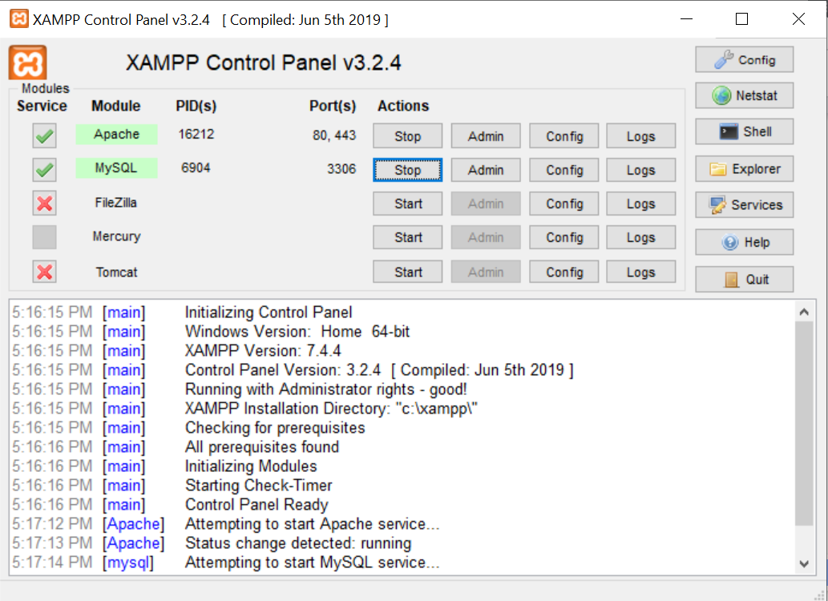

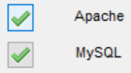

Open **localhost/phpmyadmin** and now this type of window can be seen.

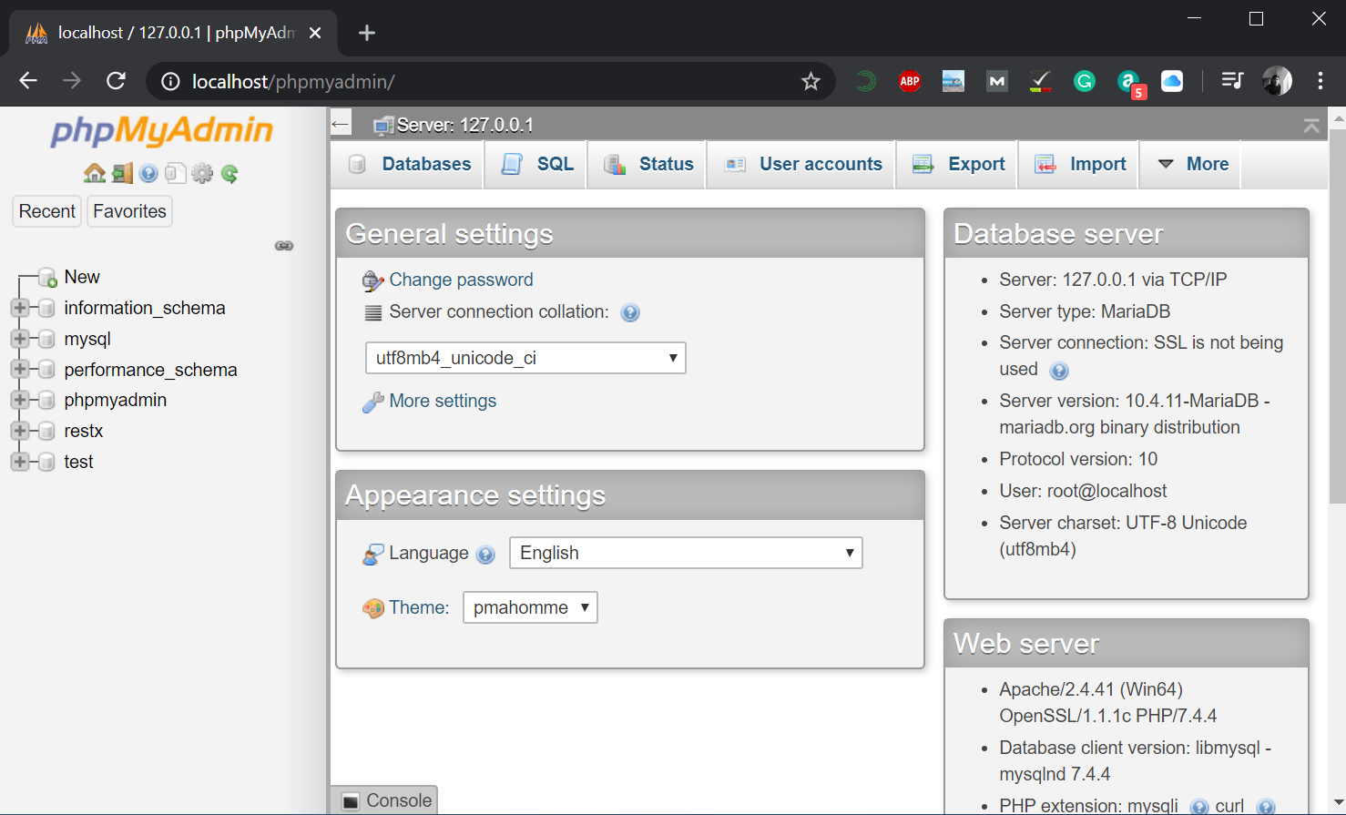

**IMPORTANT: IF SOME PART OF THE PROJECT DOES NOT WORK EVEN AFTER ALL THE INSTRUCTIONS DONE, THEN COPY THE FOLDERS INSIDE** [**REPLACABLE**](Replacable) **TO THEIR TARGET DIRECTORIES. PLEASE TAKE A LOOK AT** [**README**](Replacable/README.txt) **BEFORE DOING THAT.**

**Proceeding with project work**

* **Prepare the database**

After opening **localhost/phpmyadmin,** we have to create a new database for our project. To create a new database, go to New.

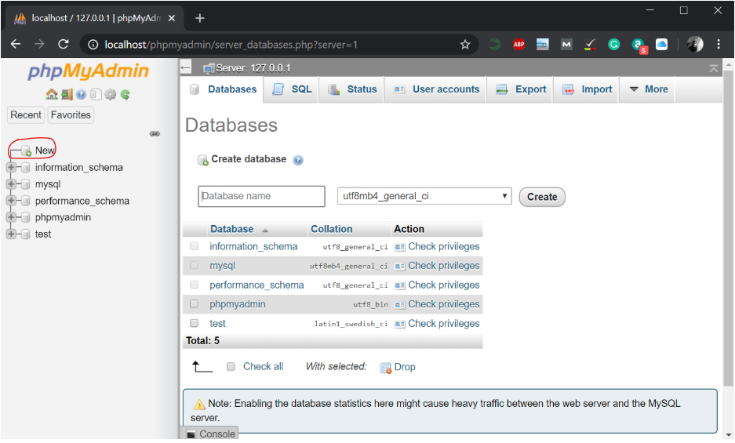

Enter a database name (here, **restx**) and click on **Create.**

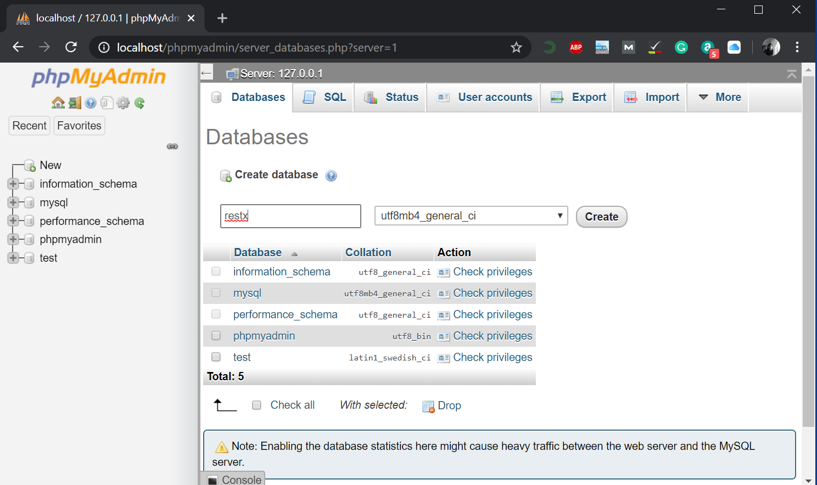

Give a table name, Number of columns and click on **Go.**

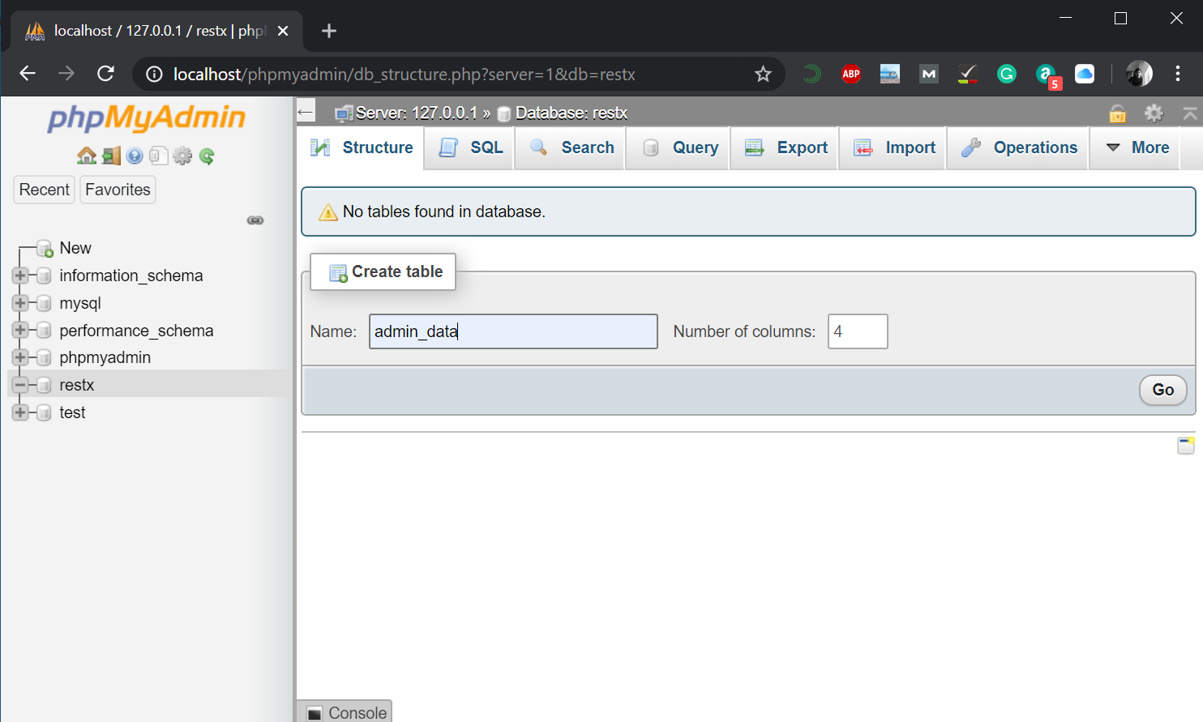

Give name and Type. Fill up accordingly.

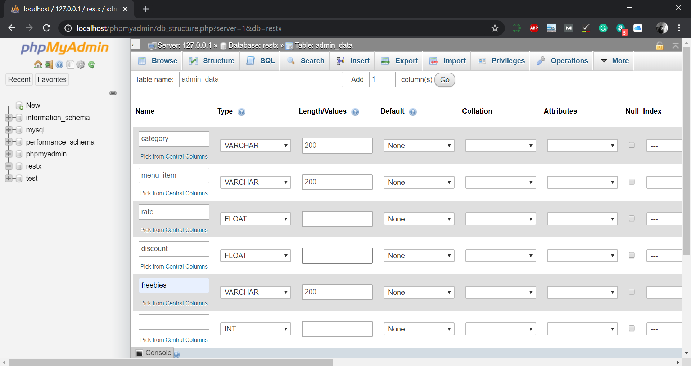

Click on **Save** and a new table under database **restx** will be created. This is a MySQL database.

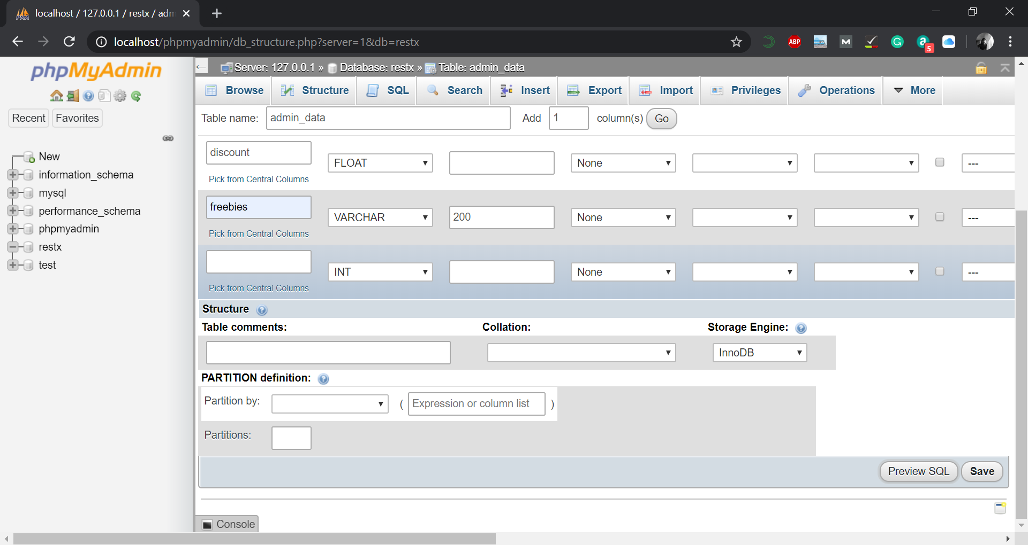

* **Create a NetBeans Java Project and connect to the database**

Open NetBeans from the taskbar. Go to **Tools -> Plugins -> Installed.** Check **Java SE, Tools** and **JavaFX 2**. Click on **Activate.**

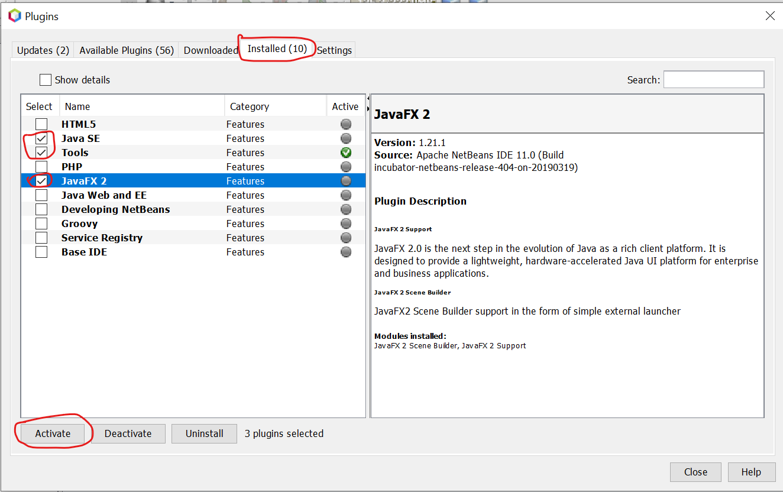

Click on **New Project icon or Ctrl+Shift+N.**

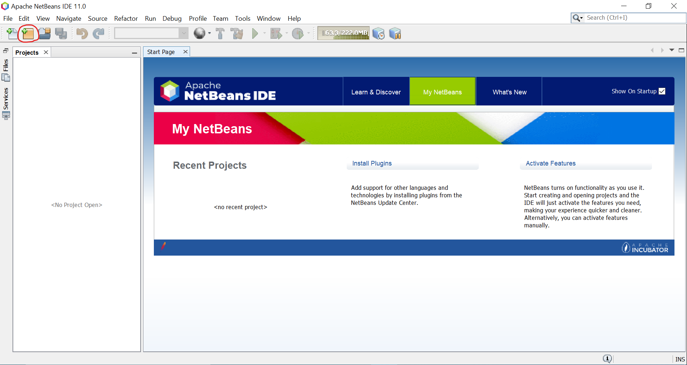

Now, do this according to the images shown. To, proceed click **Next** and **Finish** gradually.

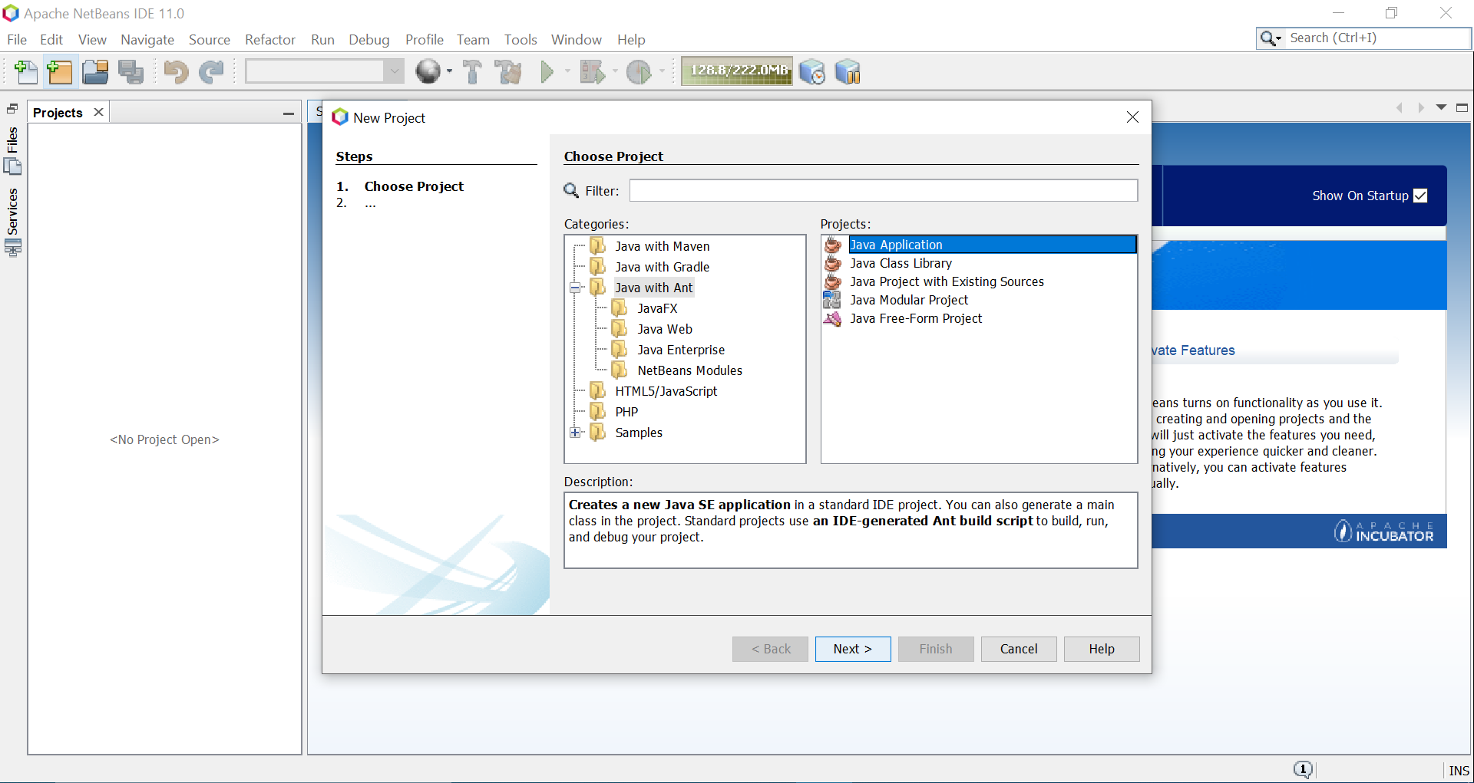

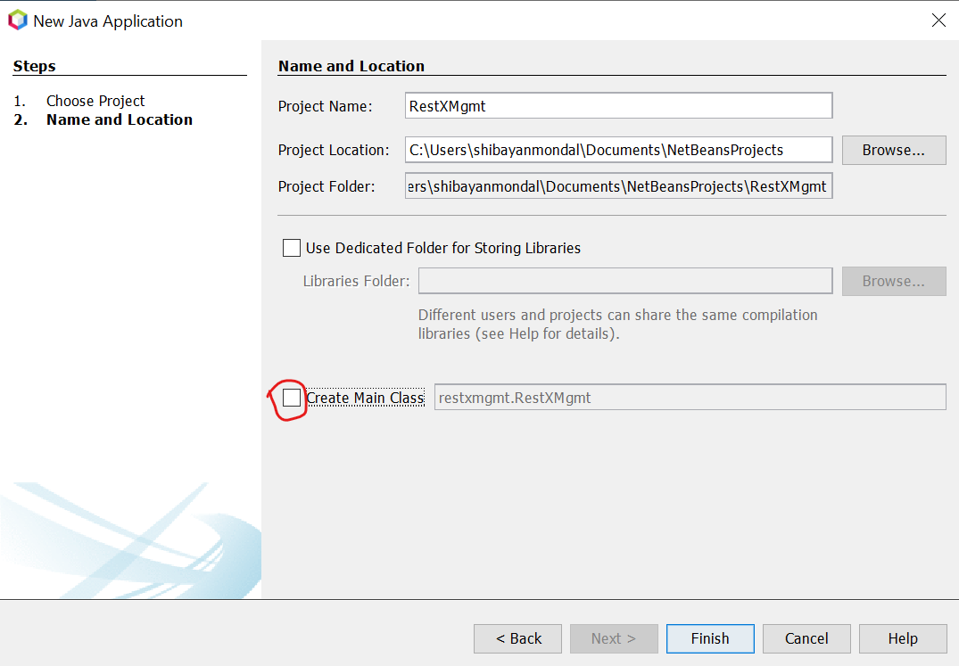

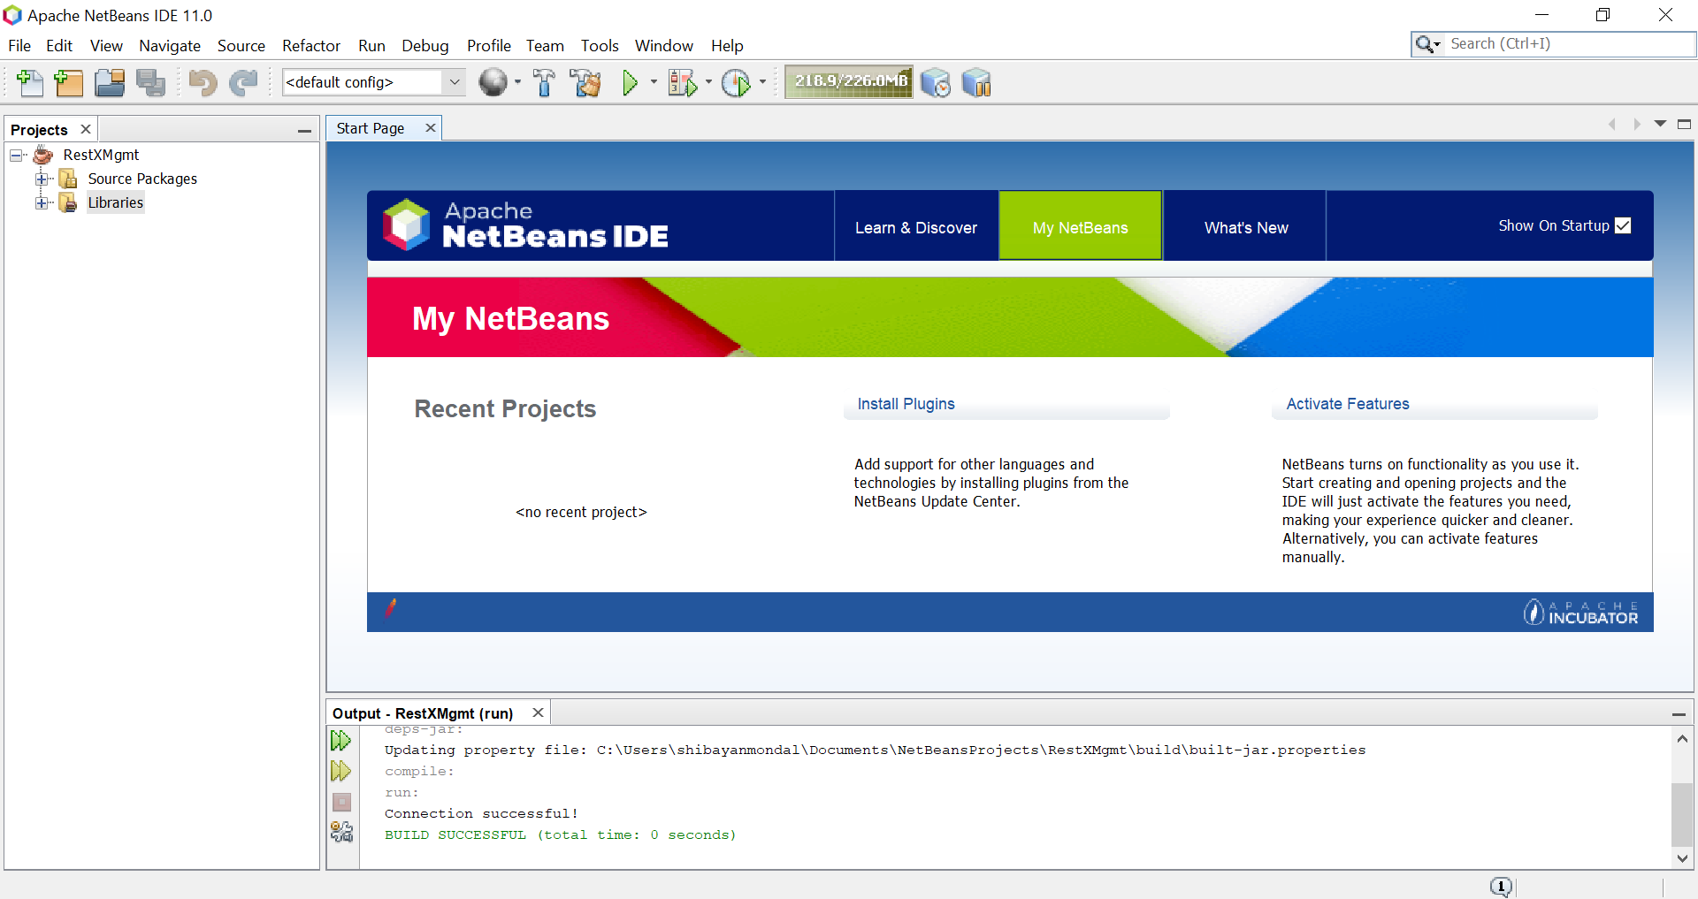

**Now, download Connector J/mysql-connector from** [**https://dev.mysql.com/get/Downloads/Connector-J/mysql-connector-java-8.0.19.zip**](https://dev.mysql.com/get/Downloads/Connector-J/mysql-connector-java-8.0.19.zip)**.** Extract the file. A file named “mysql-connector-java-8.0.19” will be created. Move it to **C:\.**

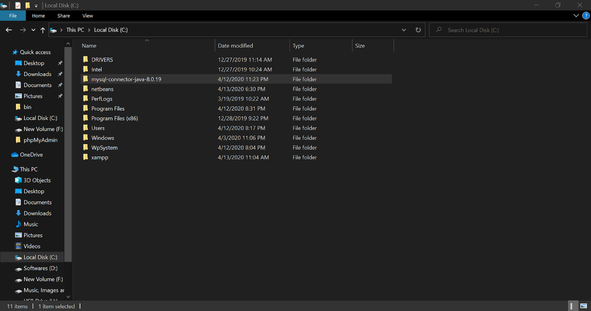

Come to NetBeans. Right click on **Libraries** and click on **Add JAR/Folder.**

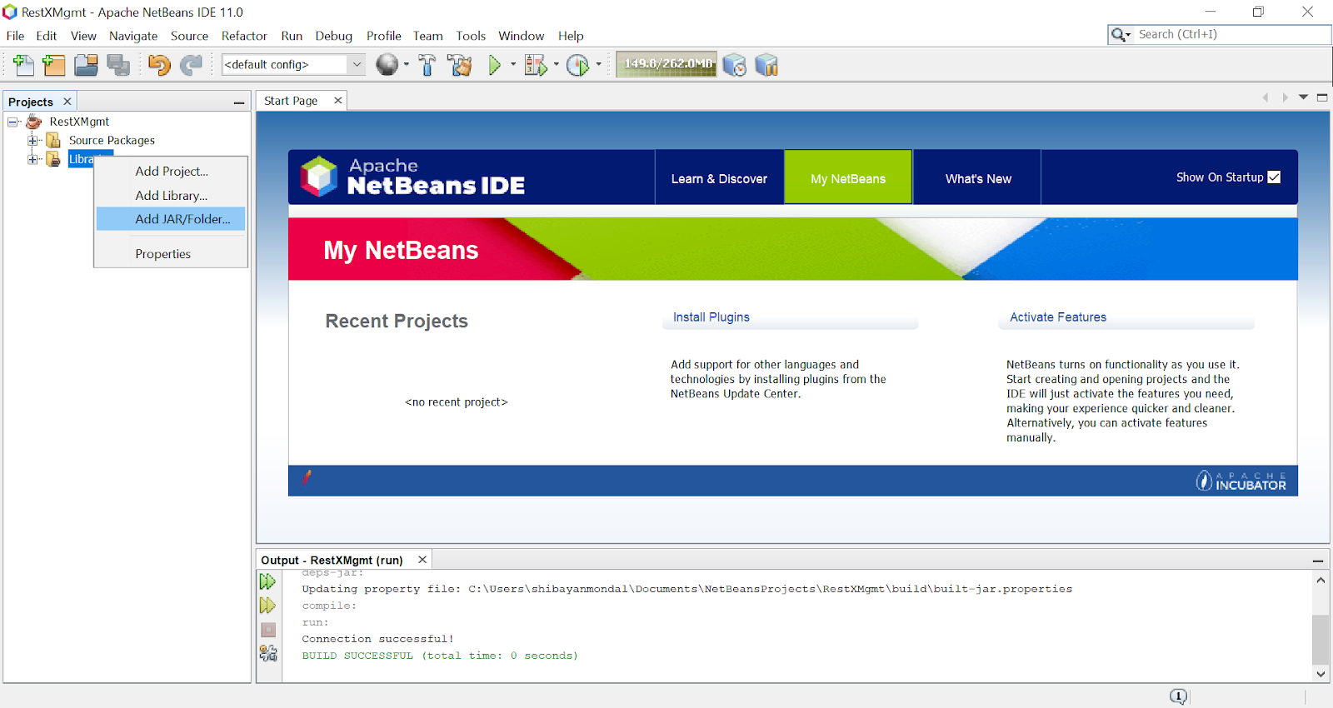

Go to **C:\mysql-connector-java-8.0.19,** select **mysql-connector-java-8.0.19** and click on **Open.**

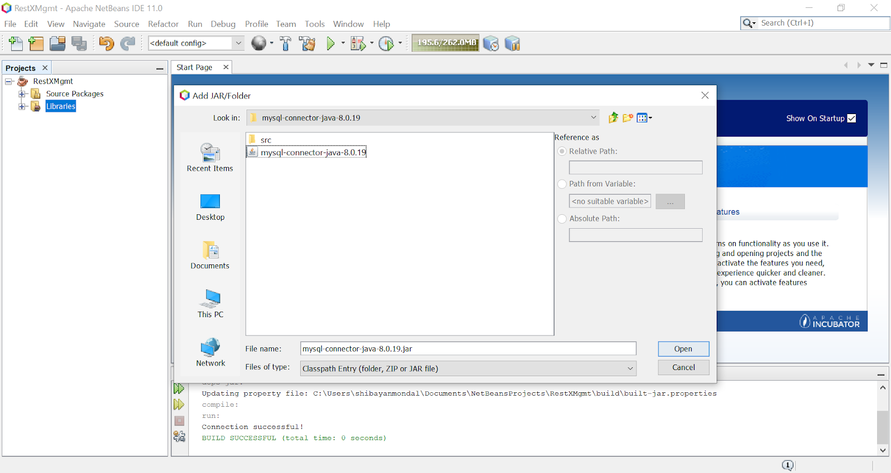

Press **Ctrl+5** to activate **Services** window. Right-click on **Databases** and click on **New Connection.**

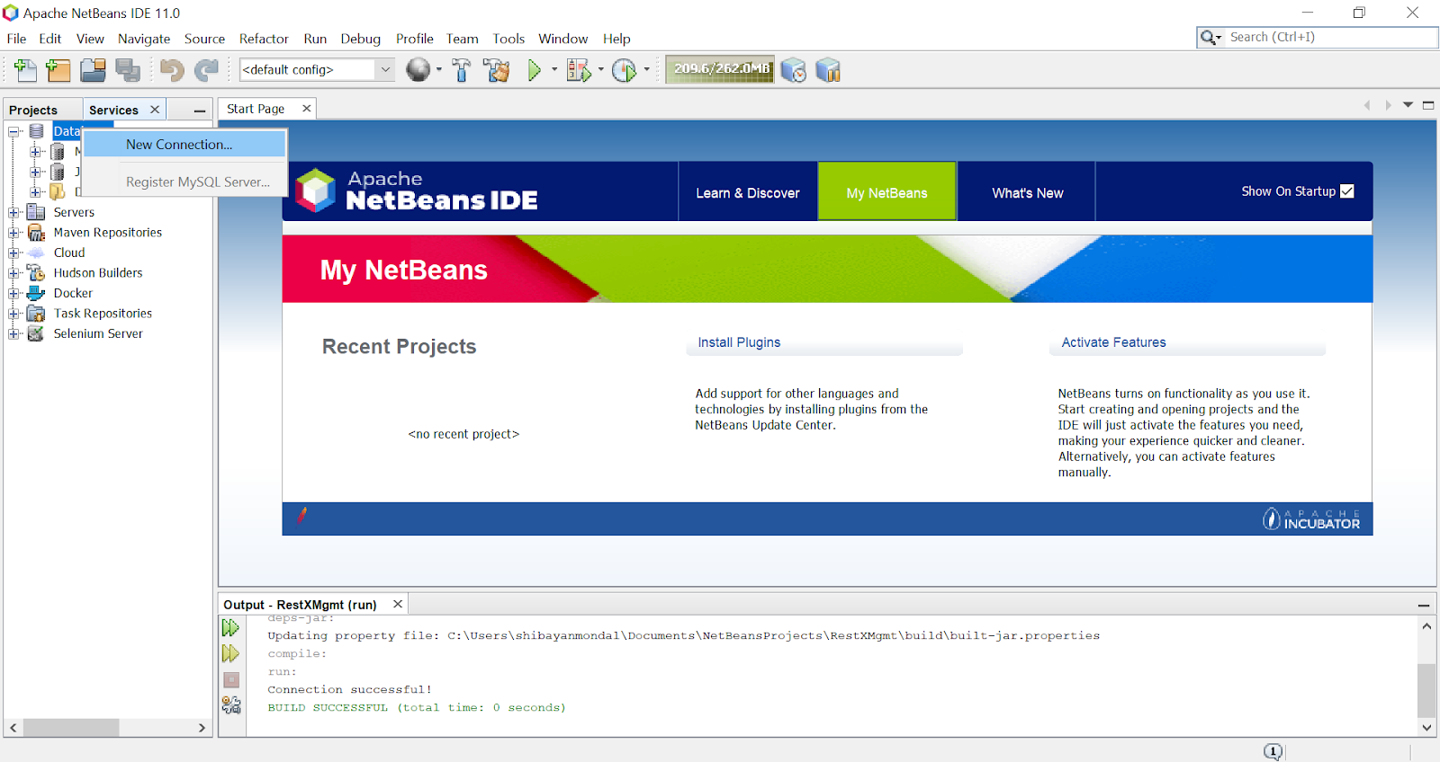

Click on **MySQL (Connector/J driver). If, MySQL (Connector/J driver) is not found then go to New Driver -> Add -> Select mysql-connector-java-8.0.19 by going to C:\mysql-connector-java-8.0.19. Rename it accordingly.**

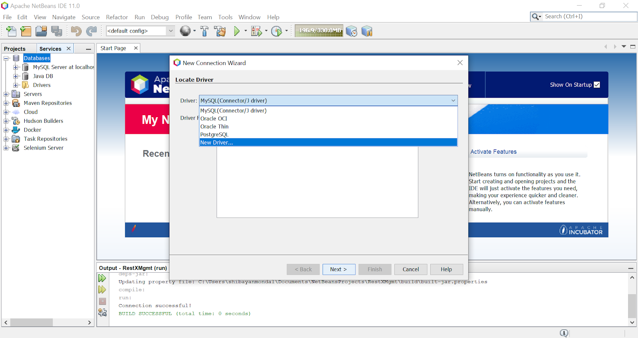

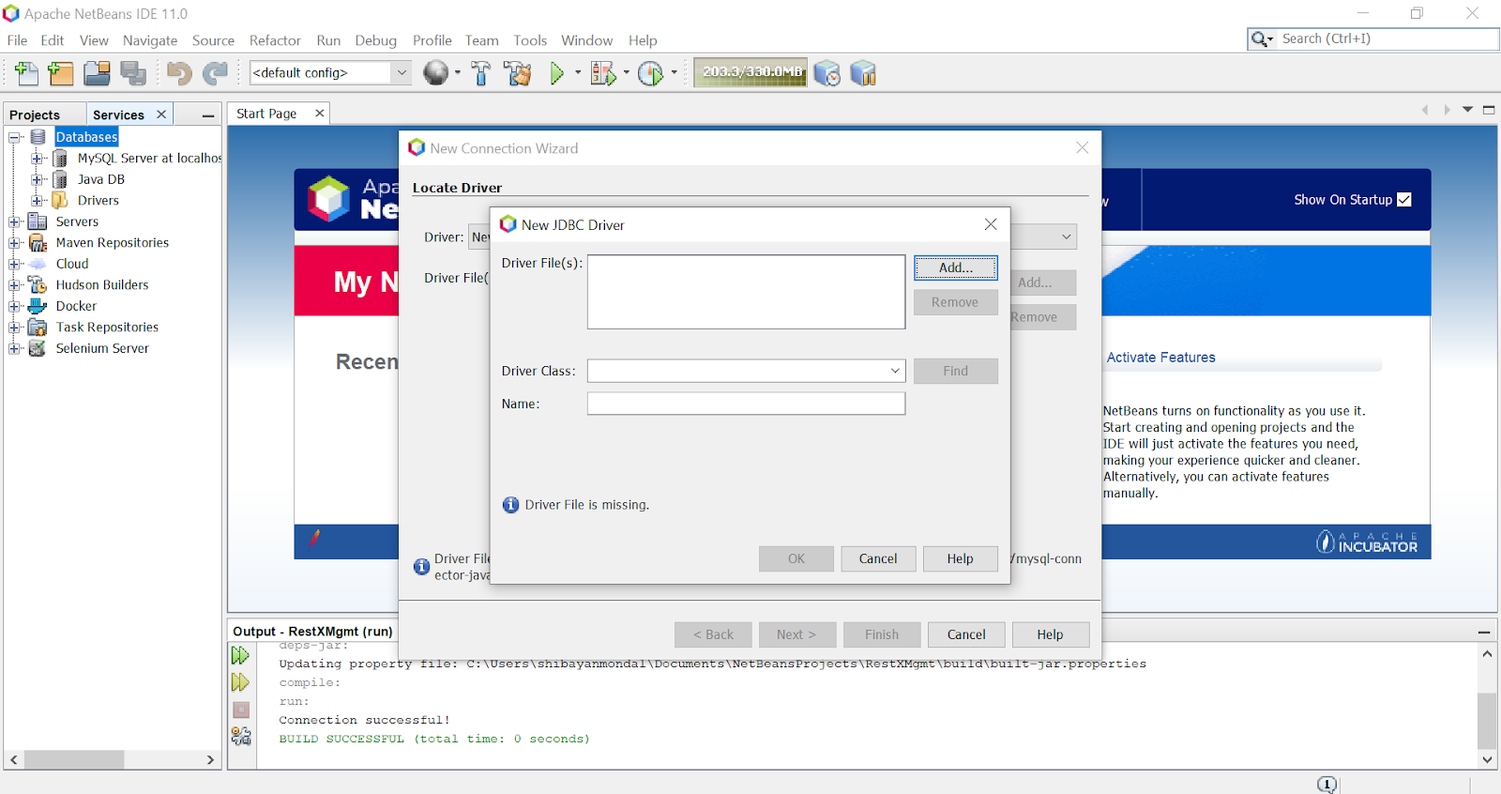

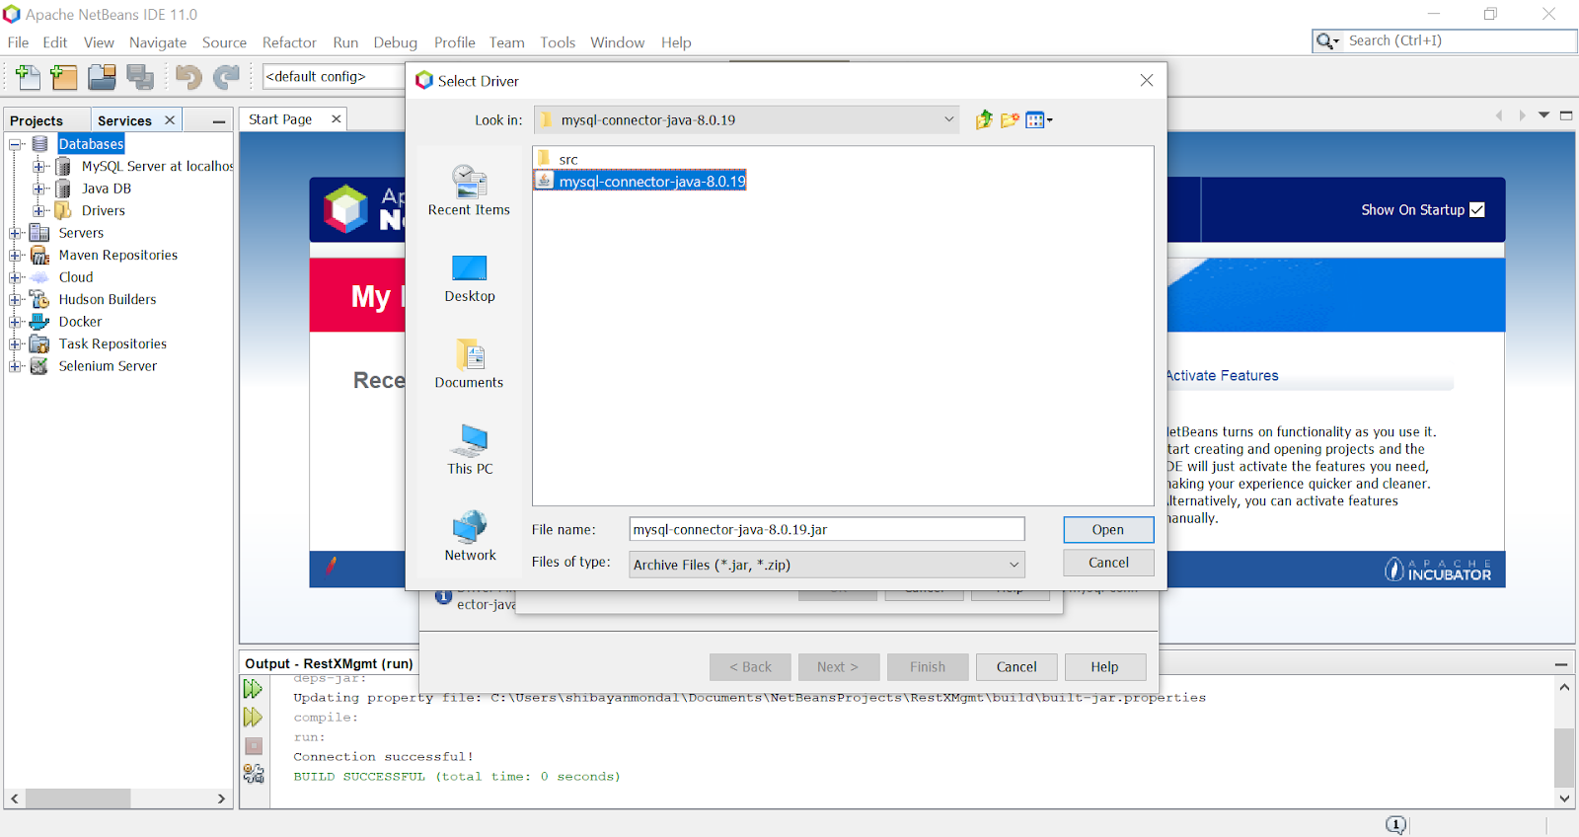

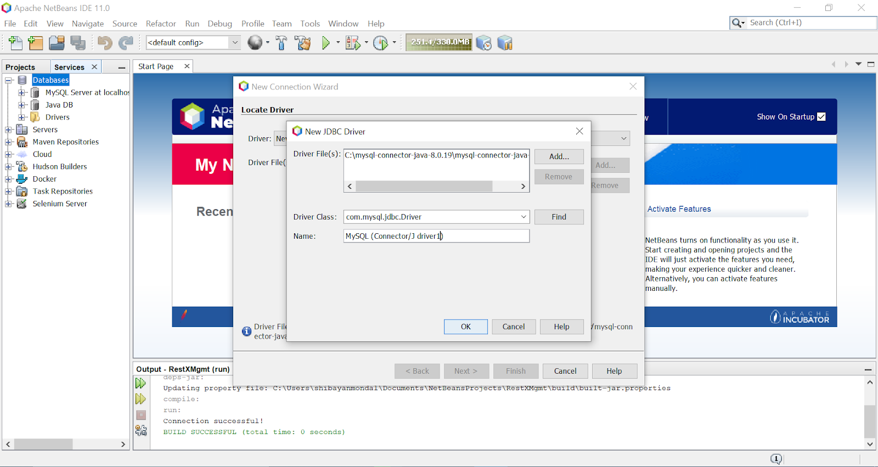

**Now, MySQL (Connector/J driver) has been created successfully and the problem is fixed. Now, click on Next.**

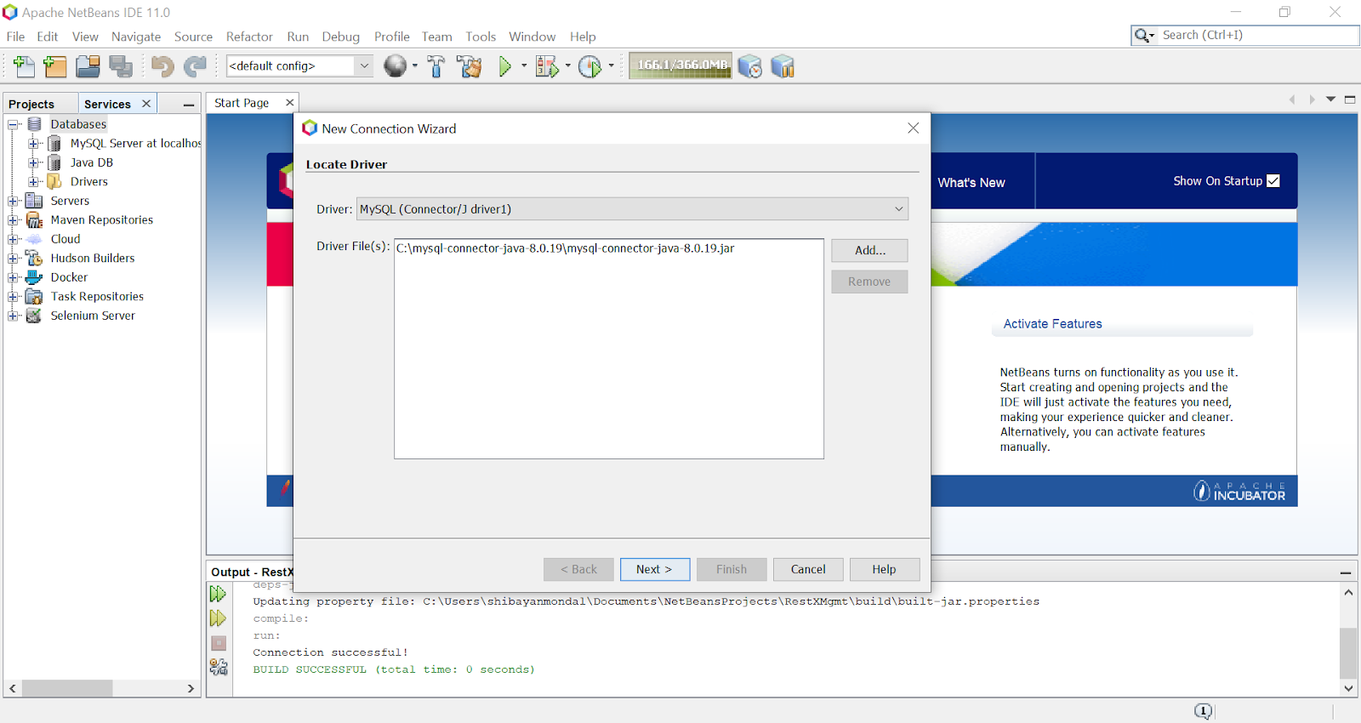

Fill the details as shown.

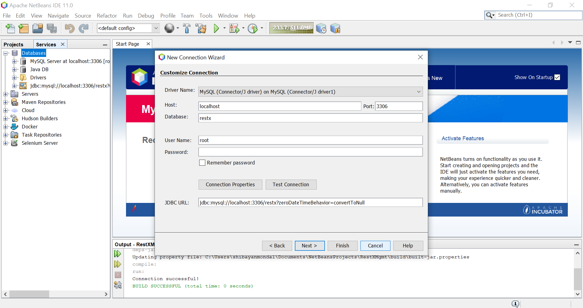

**Here is the error. See the red line why the error occurs!**

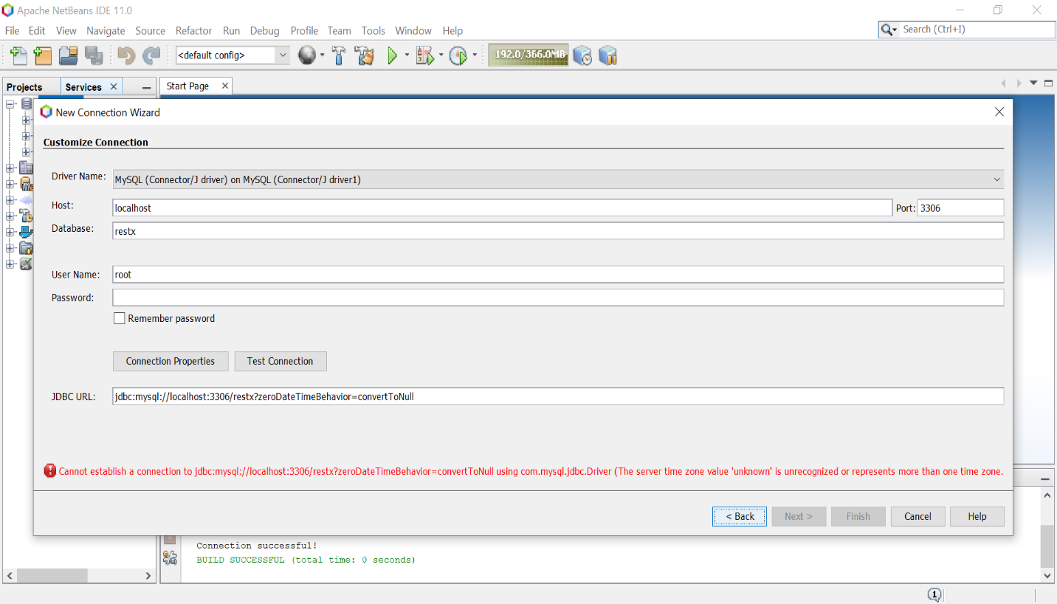

**This is how it can be fixed. The connection to the database has been successfully established.**

**JDBC URL: jdbc:mysql://localhost:3306/restx?useTimezone=true&serverTimezone=UTC**

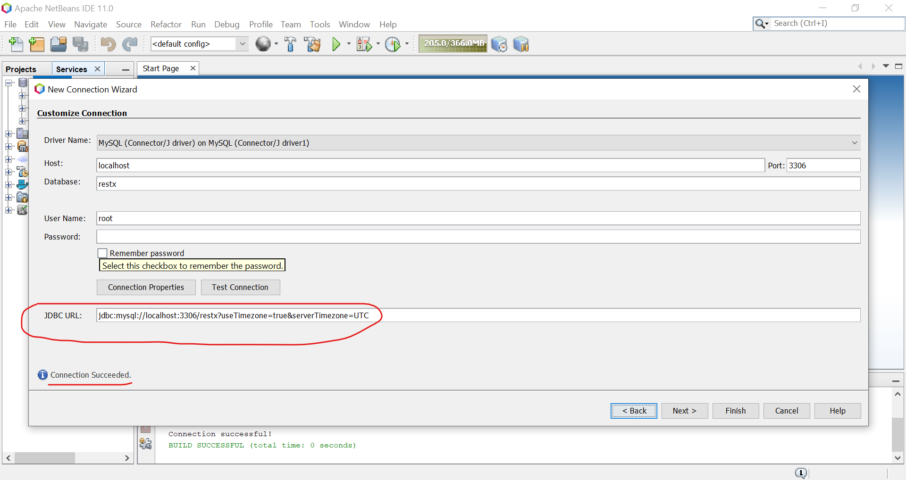

Now, just click on **Next** and **Finish.**

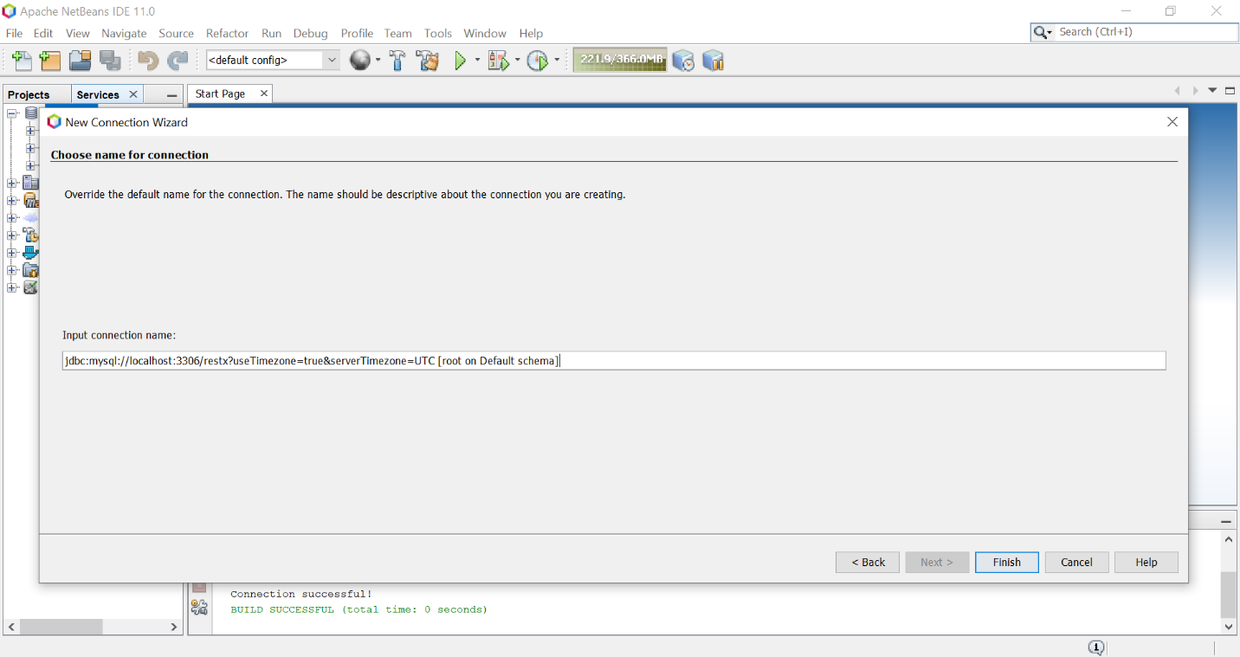

**It’s done.**

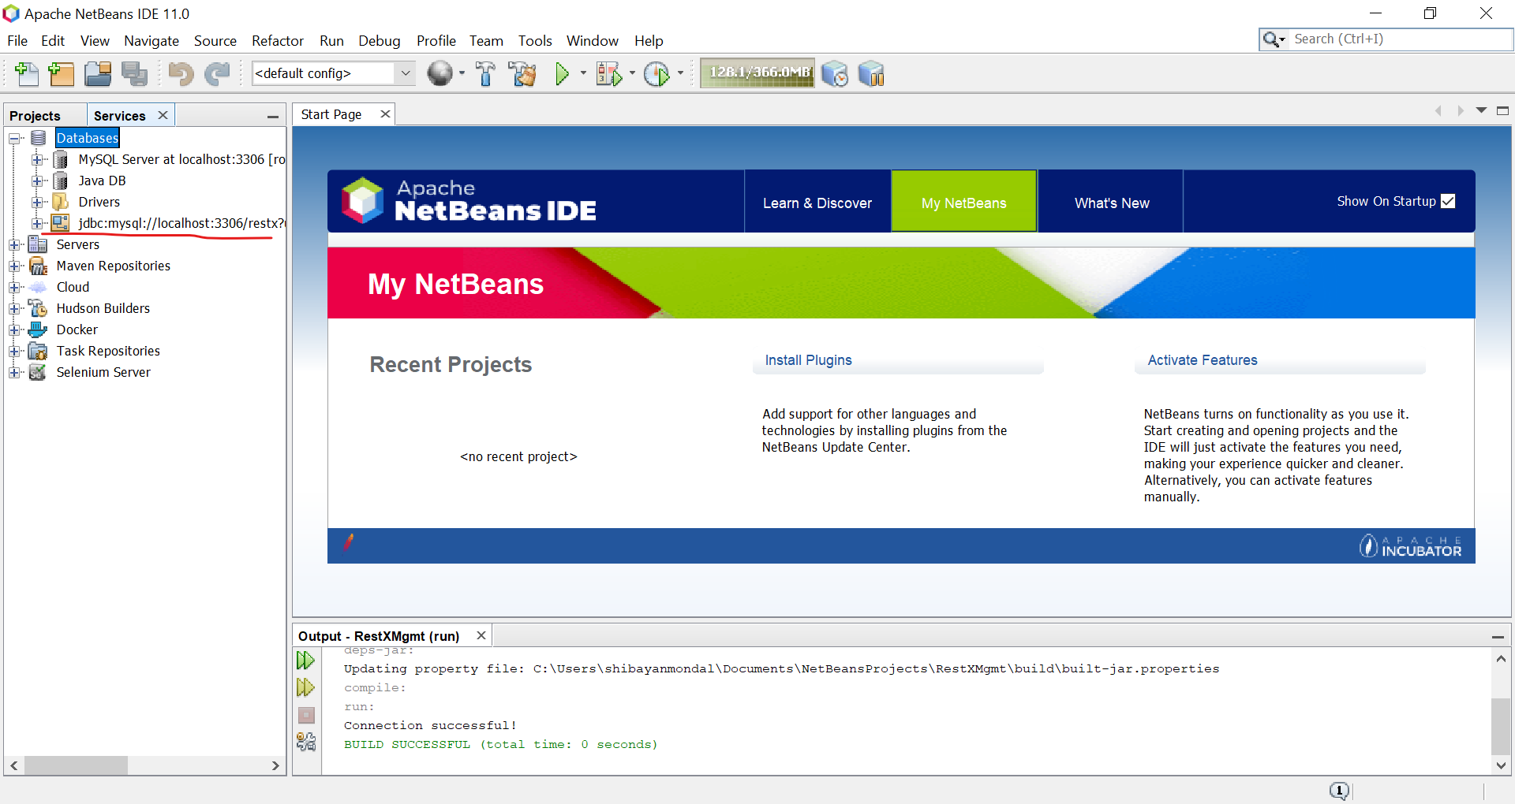

Now, we have to obtain the connection object. Create a **package “RestXInterface”** under Source Packages. Now create another package **“DBConnect”** and create a **new class “DBConnect”.** Copy the code below and paste it in the DBConnect.java in NetBeans IDE. Build the code (**F11).**

package DBConnect;  
import java.sql.*;  
  
public class DBConnect {  
   
 private static final String username = "root";  
 private static final String password = "";  
   
 public static Connection getConnection() {  
 Connection con = null;  
 String connectionUrl = "jdbc:mysql://localhost:3306/restx?useTimezone=true&serverTimezone=UTC";  
  
 try {  
 con = DriverManager.getConnection(connectionUrl, username, password);  
 System.out.println("Connection successful.");  
 } catch (SQLException e) {  
 System.out.println("SQL Exception: " + e.toString());  
 }  
 return con;  
 }  
}

Its output: **Connection successful!** will be printed like the below image if main() or any another method is given **DBConnect.DBConnect.getConnection();**

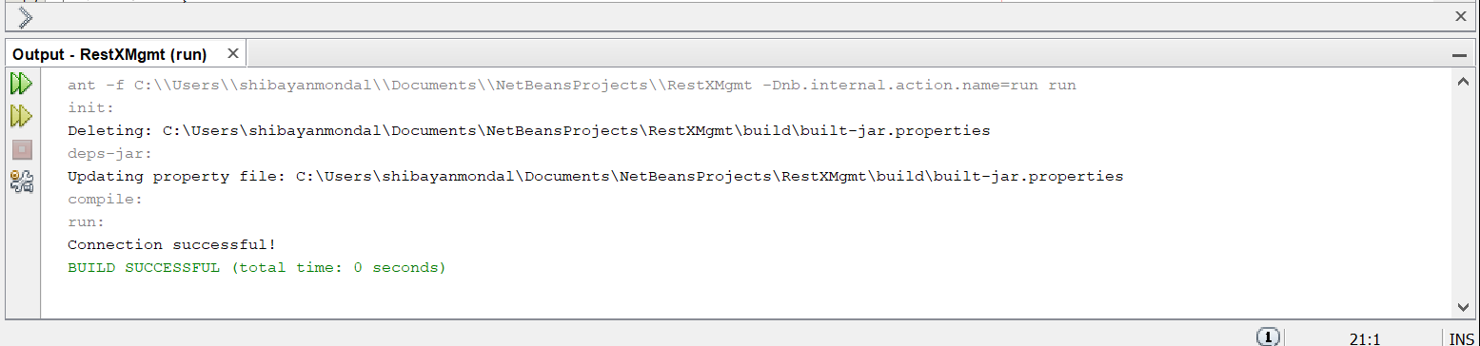

* **Running the project**

Unzip the project file [**RestXMgmt.zip**](RestXMgmt.zip) which is available with it. Open NetBeans and go to **Open Project (Ctrl+Shift+O) from File menu.** Navigate to the directory where the project .zip file has been extracted and the project can be added to NetBeans.

Now, make a clean build of the project by pressing **Shift+F11** and then **F6** to run it.

**IMPORTANT: Please take a look at README.txt before proceeding.**

* **Main components for building for this Project**

**It has three Packages:**

* + **DBConnect** : It is used to get connection value for the database.
  + **RestXInterface**: It has components for different jPanels to implement different windows.
  + **Img**: This is for getting images in the Panel. Images are downloaded from Google with **No Copyright ©** filter.

**Libraries and APIs:**

* **mysql-connector-java-8.0.19:** It is used to get the **JDBC driver for the API** to establish the connection with the database.
* **rs2xml:** It is used to get **DBUtils class** to get the data from MySQL database to the jTables or Java Tables.
* **jasperreports:** It is imported to generate bill from table datas. But it was not at last. **AWT PrinterJob** is used for printing the bill.
* **Project Workflow with screenshots:**

The application is based on two main working principle. Firstly, Managing the main database of a restaurant. Main database means database which contains main part of a restaurant and that is its **food menu.** Secondly, another main thing is **its billing system for customers.**

Take a look at first window. It is **FirstWelcomeScrn.java inside Package RestXInterface.**

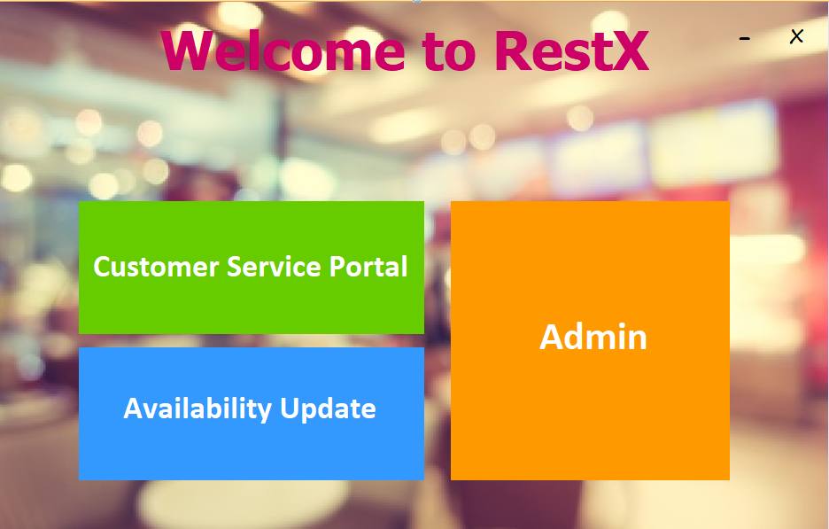

To manage main database of food items of the restaurant, the user needs to open **Admin**. A login screen will be opened. It is **AdminLogin.java inside** **Package RestXInterface.**

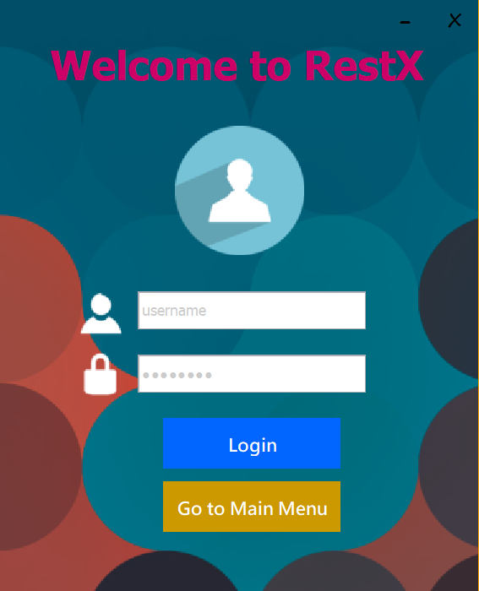

**Note: Registration form has not been implemented yet due to time constraint. As of now, username and password are manually entered to the database for testing.**

**Username and Password will be visible if you hover the mouse on login button.**

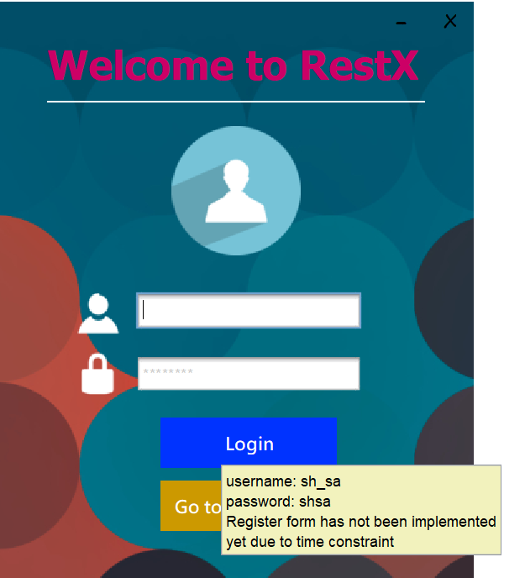

Here is the database for login. It is **login_details** table from **restX** database.

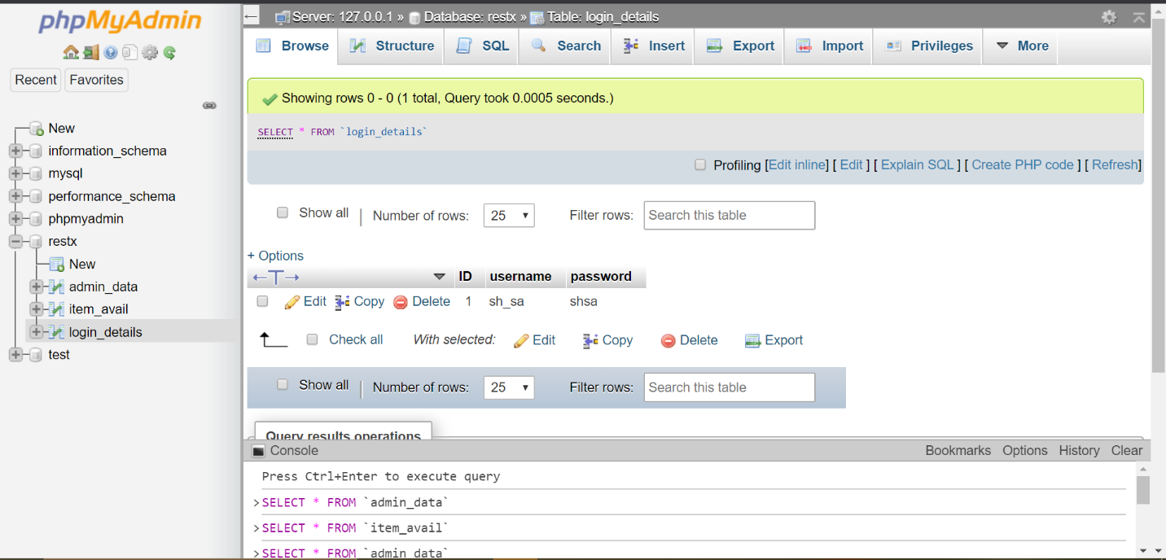

After successful login, a window will be opened to manage database of the restaurant. It is **AdminPanel.java inside** **Package RestXInterface.** Here user can **insert, update, delete** data from database. Screenshot of its database is given below.

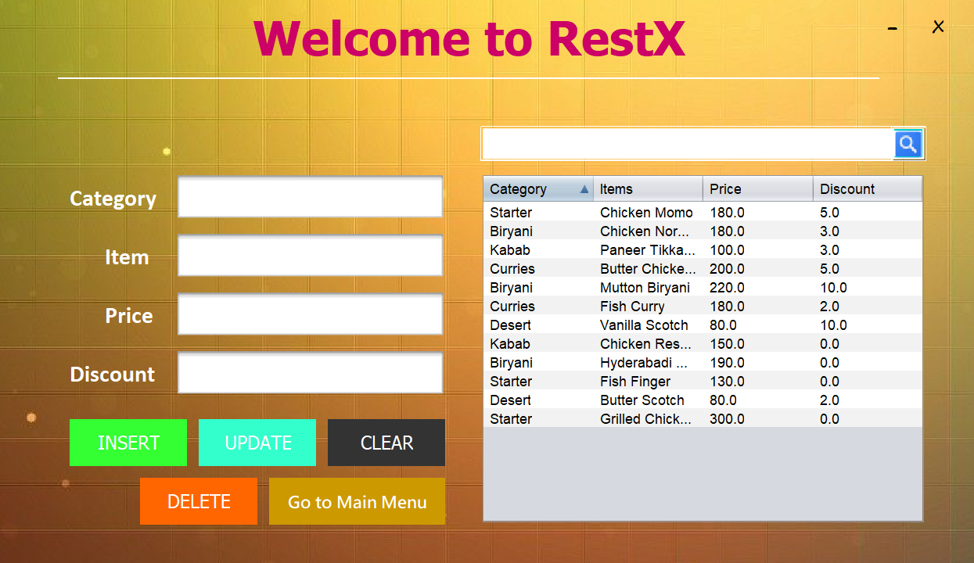

It is the main database for managing all the food items of the restaurant. It is **admin_data** table from **restX** database.

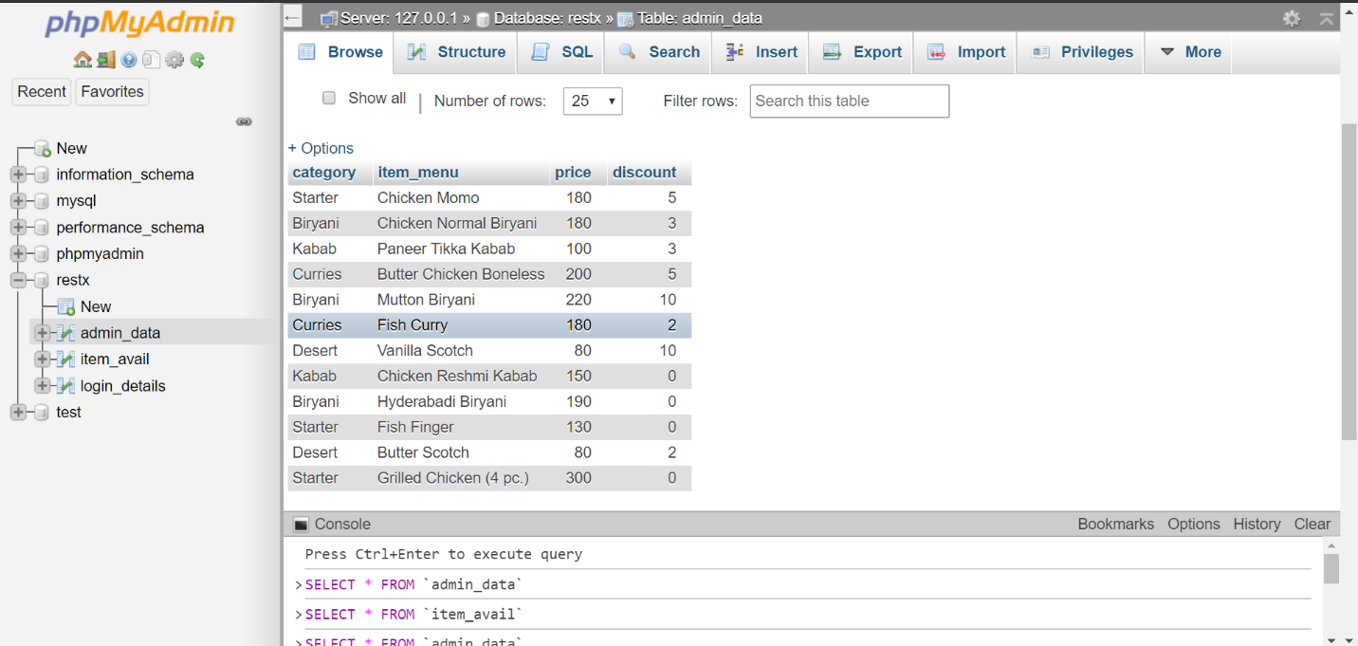

Now, come to the button **“Availability Update”.** It is used to manage the available items at that point of time. As an example, a restaurant has ItemX and ItemY in its menu. But today, restaurant has prepared only ItemX, not ItemY. So, the availability of ItemY is 0 for today, but some ItemX are available.



Here is the screenshot of Availability Update window. A user can make an item available from main database **“admin_data”** or delete an available item if its quantity exhausts. It is **AvailiabilityUpdate.java inside** **Package RestXInterface.**

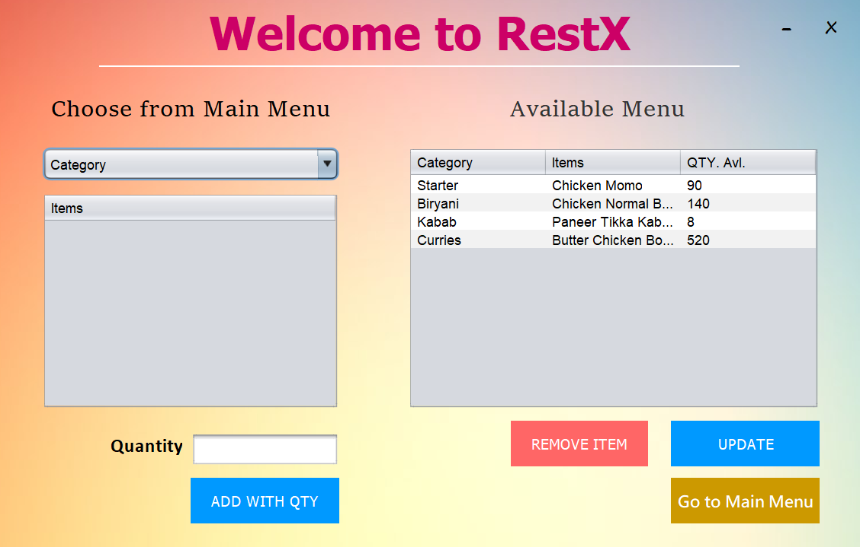

A new database is used here to track available items. It is **item_avail** table from **restX** database.

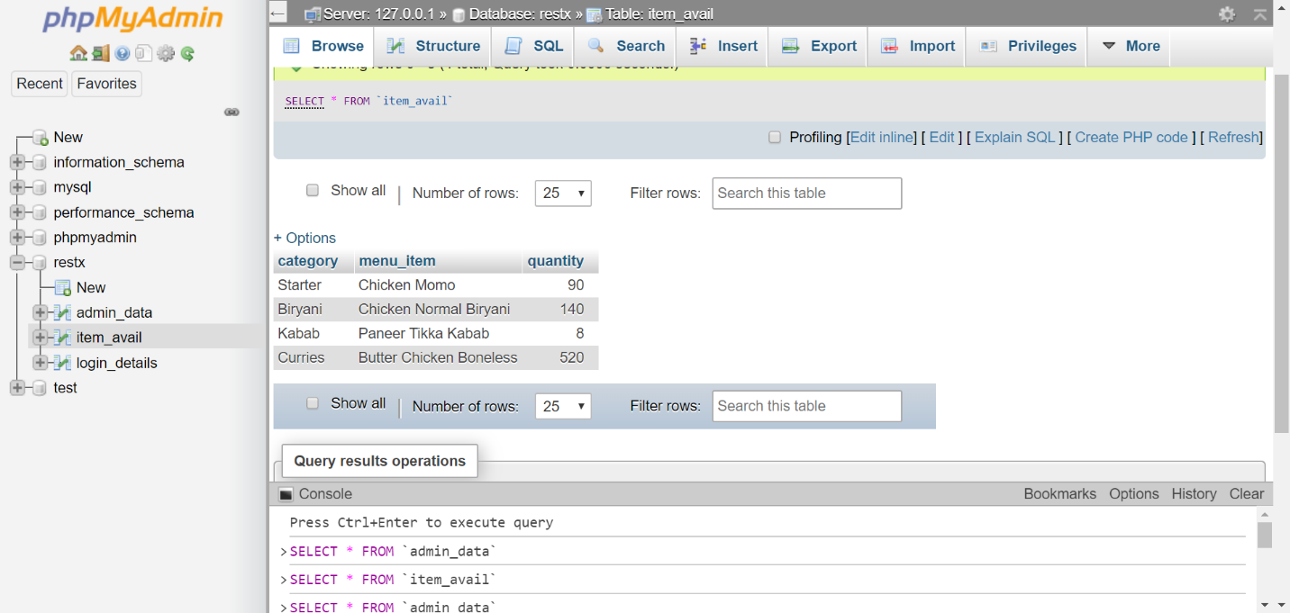

Now, come to the button **“Customer Service Portal”.** It is used for billing purpose for customers. It is **CustomerPortal.java inside** **Package RestXInterface.**

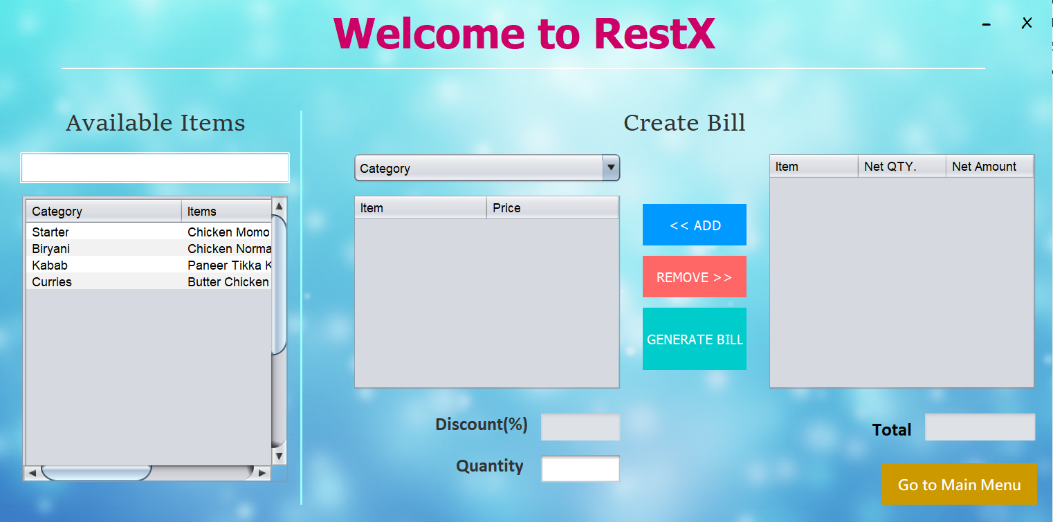

**A Sample of a generated bill from this selection.**

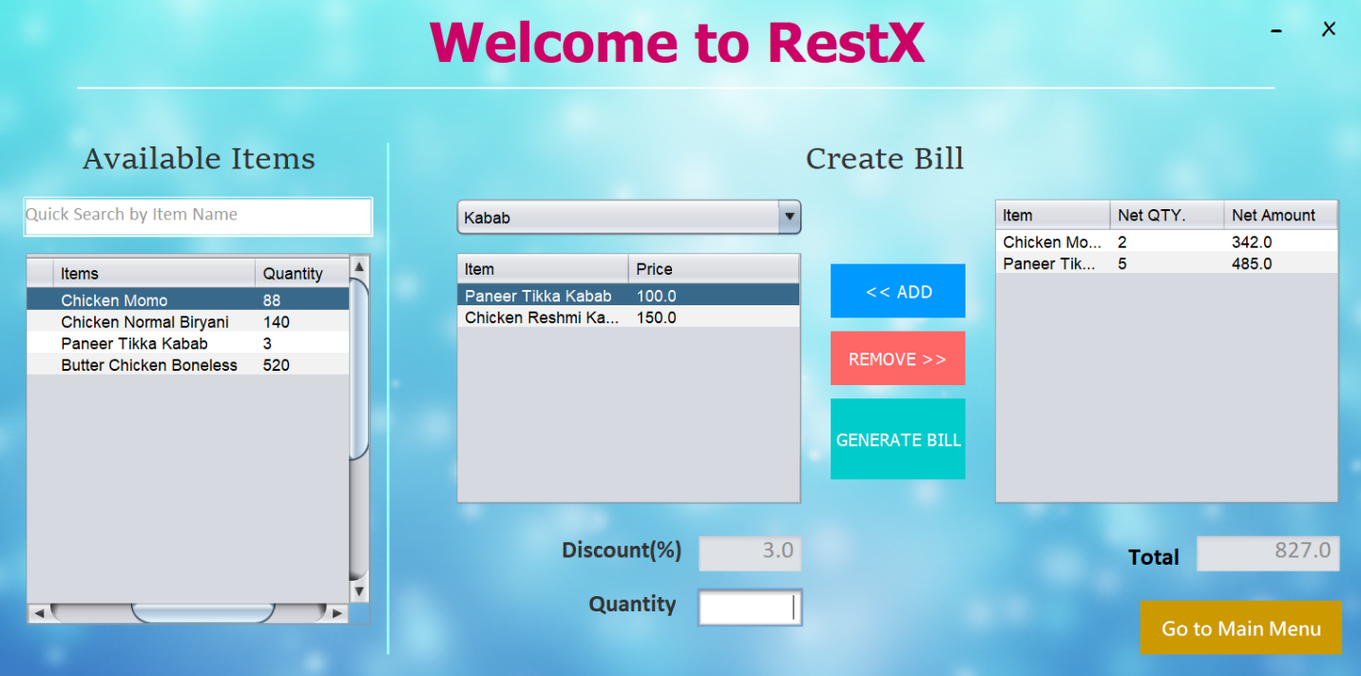

**Bill is at the next page. >>**

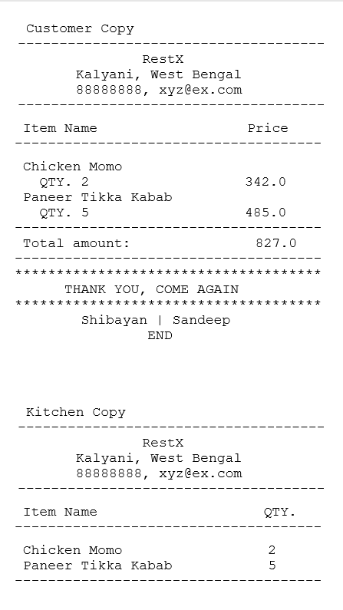

* **Demonstration of the project**

Here is the [**demonstration video**](prj_demo.mp4). It totally describes the whole project workflow with limitations.

* **Discussion:**

Despite having been implemented a lot, this project has some important things to do. Some of them are not implemented till this point of time due to time constraint. **Some features need to be added and some debug work should be done. I am talking about a few areas which I thought to implement as follows:**

* **A registration form is to be created to add a new admin.**
* **A moving/animated (not merely a .gif image downloaded from Google. I would design it on my own) Splash Screen.**
* **There are three buttons in the FirstWelcomeScrn. They are made semi-transparent. But, I also wanted to give them a mouse hovering effect like other buttons are given. But jPanel does not support normal transparency effect.**

**Here is the code.**

private void jPanel_cspMouseEntered(java.awt.event.MouseEvent evt) {   
 jPanel_csp.setBorder(BorderFactory.createLineBorder(Color.white, 1));  
 jPanel_csp.setBackground(new Color(0,0,0,50));  
 jLabel_csp.setForeground(Color.white);  
 }

new Color(r,g,b,a) in which a stands for alpha responsible for transparency. But it is not working here. Take a look.

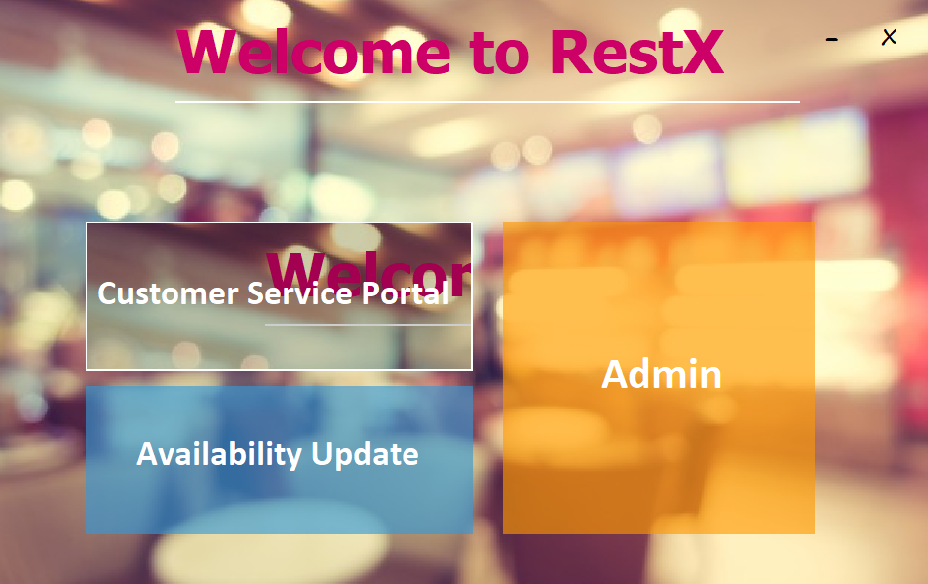

**Overall, it is still an all-round nice application for restaurant management.**